Best Management Practices
For
Communities in Coastal Georgia

Date of Last Revision 2/2026
Introduction..................................................2
Maintenance and Management......................3
Plant Management……………………..….…....7
Lake Bank/ Stormwater Pond Management.....15 & 88
Wildlife Management....................................20
Native Plant Guide……………………………...55
Nature Based Solutions………………………..76
Sustainability…………………………………....81
Conservation Easements & Open Space…..…84
References & Resources...............................92

Introduction
Coastal Georgia has a rich and diverse ecosystem that is very unique. This can sometimes create challenges for new property owners and residents who are unfamiliar with Coastal Best Management Practices (BMPs) for yard and lawn maintenance. The importance of environmental education and understanding the responsibility of proper care can not be overstated. The decisions made in our coastal communities affect our estuaries and oceans in a profound way.
We, as stewards of the land, must manage and preserve this beautiful place to respect its rich history and setting. This is an educational tool for residents, realtors, golf course professionals, and property management associations to feel better equipped for questions about property ownership in Coastal Ga, with particular focus towards landscaping and environmental practices.
This comprehensive guide for coastal Ga communities was assembled through the Collaboration & Training Program of the Sapelo Island National Estuarine Research Reserve (SINERR) in partnership with the University of Georgia Marine Extension and Georgia Sea Grant. A special thanks to consultants from the Coastal Resource Division of the Georgia Department of Natural Resources, Wildlife Resource Division of the Georgia Department of Natural Resources, the Environmental Protection Division of the Georgia Department of Natural Resources, and the Nature Conservancy, Georgia Native Plant Society, and Coastal Wildscapes who contributed feedback and information to complete this guide. Please see the up to date Recourse Contact list on the Green Communities page of the SINERR website for contact information for these consultants.



Maintenance and Management
Your Yard Maintenance Team
While there are many options available for yard services, choosing the correct team for your specific needs can be difficult. Make sure to talk to the manager when discussing your options and landscaping plan. Many times, landscapers will do a one-size-fits-most approach to landscaping, because it is easier and cheaper.
One of the goals for this guide is to help you understand how to properly inform your landscaping team of your specific needs. Information is key when coming up with your landscape plan, both with your landscaping architect and your maintenance team. It is recommended that they review a copy of this BMP.

General Landscaping Management
• Do not apply pesticides, herbicides, and fertilizers during irrigation, within 48 hours of predicted rainfall, or when
wind speeds are above five miles per hour.
• Do NOT blow landscaping waste into street or storm drain inlets or use a hose to rinse landscaping residue or debris off paved surfaces
• Sweep up residual sediment, leaves, and landscaping waste to prevent dispersal by wind or through contact with rain
or irrigation water runoff. These flows can wash the waste into the lakes and eventually the local watershed
• Proper dispose of landscaping waste:
– Grass clippings, tree leaves and trimmings, bushes/shrubs and trimmings, tree limbs/branches (< 4 inch diameter)
in a green waste container or even better, leave them on site as mulch to eliminate hauling waste.
– Tree limbs and branches (≥ 4 inch diameter) at a permitted landfill or by composting/mulching.

Irrigation Management
Water conservation is very important. In Coastal Ga, water may not seem as precious of a resource as in drier regions, but its proper application is just as important! Reducing the pull from our aquifers is vital. Over-watering yards is not only bad for the environment but also costs homeowners a lot of money! Utilize these tips to help with water conservation:
• Time and locate irrigation heads to minimize runoff.
• Minimize irrigation runoff by using an evapotranspiration-based irrigation schedule and rain sensors.
• Avoid over-watering landscape areas that are already saturated not only to conserve water but to avoid runoff water, which may
carry fertilizers, nutrients, and pesticides into our lakes!
• Regularly inspect the irrigation system for leaks.
• Ensure sprinklers are not directed to hardscape/concrete.
• Use borders at pavement edges to reduce overspray and runoff.
• Use rain harvesting techniques like rain barrels or cisterns to harvest water from gutter systems of your home to use as landscaping water supply. You can also use this non-potable water for emergencies, making it a resilience feature. See the Nature-Based Solutions section to learn more.
• Utilize native plants in your landscaping that are already accustomed to the amount of local rainfall and do not require added irrigation. See the Native plant guide to learn more.
•Design your landscaping layout with irrigation in mind! Do not put plants with higher water demands in areas you know to be drier and will thus require more irrigation. Placing native plants in their natural areas is always best. Consult the Native Plant guide for more information.

Soil Management
Soil sampling is HIGHLY recommended to determine your exact requirements and should be offered by your landscaping company before applying any direct fertilizer or treatments. Having a complete soil test will tell you what your soil does and doesn’t have so excessive use is avoided. This not only saves you money in the long run, but also is ecologically friendly!
Coastal Ga as a whole tends to have higher Phosphorus levels. It is common practice for landscaping companies to utilize 10-10-10 fertilizer (Nitrogen-Phosphorus-Potassium). One disadvantage of any inorganic fertilizer is they may crust on top of the soil rather than soaking deep into the roots. This can be problematic, particularly for waterfront properties, as the Phosphorus can then seep into the lakes/rivers/ponds, causing increased plant production and algae blooms which then cause issues with fish and aquatic plant populations including lake turnover and fish dieoff!
Another issue with generalized fertilizers is that they don’t enrich the soil long-term, but provide a quick fix of nutrients. Excess Phosphorus can also kill the symbiotic mycorrhizal-forming fungi that live in the soil. When microorganisms in the soil die, it causes an inability for the plant to absorb iron and other micronutrients. It can shut down the plant’s production of phytochelatins. These organic molecules help regulate iron intake and other important nutrients.
In contrast to synthetic fertilizers, organic fertilizers come from natural sources such as manure, compost, blood meal, green sand or bone meal. The downside is that organic fertilizers have lower concentrations of nutrients. However, they build up in the soil over time and provide nutrients for microorganisms throughout the year. These soil microbes work in tangent with your plants, helping them absorb nutrients and fight disease. You can also get synthetic fertilizers that contain only one of each of the primary nutrients as an alternative. Nitrogen sources include ammonium nitrate (33.5-0-0), urea nitrogen (46-0-0), sodium nitrate (16-0-0) and liquid nitrogen (30-0-0). Phosphorus is provided as 0-46-0 and potash as 0-0-60 or 0-0-50.
It is recommended that fertilizer also be localized to needs. Do not apply fertilizers all the way to the edge of your yard, particularly if you live along lake banks! Please monitor all fertilizer usage and consult which type of fertilizer your company is using and why. Again, soil samples (at multiple spots in your yard) are highly recommended before any fertilizer use. The UGA County Extension office provides homeowners with easy to use soil sampling send-off kits.
Pest Management
Coastal Ga has numerous pests to yards that can become a problem quickly. But over-use of non-targeted pesticides have caused what is now being dubbed the ‘Bug-pocalypse’. While that may not sound bad to many who have an aversion to our creepy crawlers here in Coastal Ga, bugs play a crucial role in our ecosystem and the complete irradiation of your yard's bugs is a very costly mistake! Many bug species are important pollinators, and without their help, your plants will die! Even male mosquitos (yes, mosquitos) are great pollinators! Only the females bite, so overspraying of mosquito sprays have reduced our pollinator numbers across the county. You can request your home or community be removed from your area’s mosquito spray zones. If you keep bees on the property, this is extremely important! Use these pest control practices to prevent unwanted consequences:
• Select a pesticide specifically for the pest to be controlled. If your landscaping company can not determine the specific cause, you can identify the specific problem by taking a sample to your local nursery.
• Do not over spray or overuse pesticides. Follow all directions for each pesticide application since many do not need to be repeated in a certain timeframe. Overuse can cause accumulation of chemicals in the soil, which then leads to lakes and causes issues with aquatic invertebrates that help clean our waters and feed our fish. Invertebrates like dragonflies can quickly be killed off by aquatic pollution of insecticide and they are the number one predators of mosquito larvae, who unfortunately can typically survive these kill offs due to the mosquito larva stage being more hardy.
• Use mechanical and/or natural methods to remove pests first. This may reduce the need for chemical treatments which can be more costly to begin with. See nature based solutions section for more information.
• Apply ready-to-use non-aerosol pesticide, herbicide, or fertilizer products instead of mixing your own concentrates. ‘Mosquito dunk’ pesticide discs are a fantastic way to prevent these pests from occupying pools of water without harming other insects or birds.
• Apply pesticides in conjunction with pollinator sleeping habits. Do not apply aerosol pesticides around beehives during the day! Wait until after dusk, when bees are safely in their hives and butterflies are roosting in trees.
• Consider alternative management methods such as pest-resistant plants, sealing entryways, removing food sources, and eliminating nesting sites. You should always start with natural, non-toxic methods for pesticide control if you can.
See the Wildlife Management Section for more information and specific wildlife control techniques.

Plant Management
Why Your Landscaping Choices Matter!
Landscape Plans often include a wide variety of plants. These choices influence not just the look of your property, but also the health of the surrounding areas! Where you plant certain plants not only impacts the design, but can be the difference between a thriving yard and one that requires costly maintenance and replacement. It can also cause issues with neighboring yards or the entire property! Using native plants, plants that are correct for your yard, and utilizing proper design for wildlife can save you money and headaches!
Native, Ornamental, and Invasive Plants- What's the difference?
The benefits of using native plants can not be overstated. Not only are they cost-effective and reduce the need for maintenance, but they benefit the environment and local wildlife communities. Ornamental plants are non-native plants that while not invasive, are purely for looks and do not serve an ecological function (i.e.- water filtering, food for wildlife, habitat space, etc). Invasive plants are plants from different ecosystems that can run unchecked in local soils. They are often ornamental plants brought in as cheap or easily accessible options that are later discovered to take over a landscape. They can be very costly to property owners due to their rapid ability to displace native plants and grow unchecked since native animals do not typically utilize them as a food source. They often come with other unseen consequences such as leaching extra nutrients from the soil, affecting surrounding plants or in some cases they can release toxins into the soil to prevent other surrounding plants from surviving.
It only takes one invasive plant to cause environmental harm! Invasive species are known for their rapid spread and only one on property can quickly become hundreds within a few years. Please have your landscape team monitor regularly and treat all invasive species quickly to prevent spreading them into your neighbor’s yard or club property.
Invasive Plants to Avoid and What to Plant Instead
Identifying invasive plants currently on your property is vital. Many members do not realize that invasive plants have been accidentally planted in their yard and are surprised how many there can be without realizing it. If in doubt, go to Georgia Native Plant Society(Gnps.org) to check.
These are the main invasive plants that Landscapers mistakenly place in yards (there are always more to be on the lookout for though) and what to plant instead:
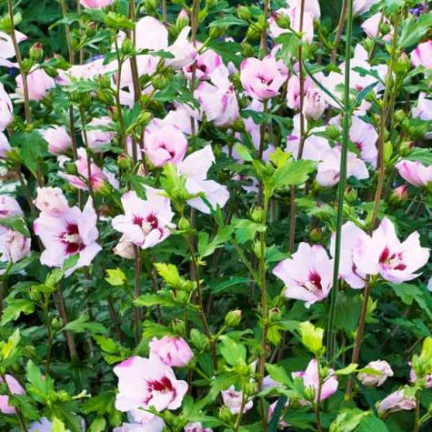
Rose of Sharon (Hibiscus syriacusc) is a common invasive plant mistaken for the native Swamp Rose Mallow (Hibiscus moscheutos) or the Confederate Rose (Hibiscus mutabilis) both of which are much better options for your yard! Both of the native hibiscus species are great for tortoises like the native Eastern Box Turtle.

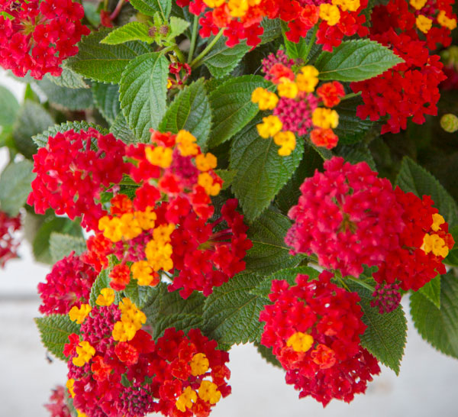
Lantana (Lantana camara) is mostly commonly sold as a butterfly and pollinator attractor, but make no mistake, it can be highly invasive and easily spread to other parts of your yard. It can displace the native variety (that is safe to plant) which is commonly referred to as Golden Lantana or New Gold Lantana. The native variety is bright yellow. You can also plant Salvia spp. in your yard instead as they are great pollinator native plants. All lantana species are also toxic to dogs if ingested.

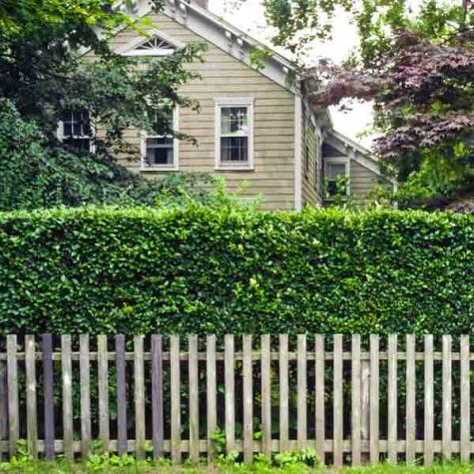
Chinese Privet (Ligustrum sinense) is often brought into yards when owners complain of deer browse. Although it is deer resistant and makes a great hedge, it also can outcompete native species and spreads quickly! It is recommended instead that property owners use Inkberry (Ilex glabra) or the native Fetterbush (Lyonia lucida) when looking for hedge plants. Note that inkberry does have toxic berries to dogs, but most dogs will not eat the berries since the leaves can be prickly to get through.

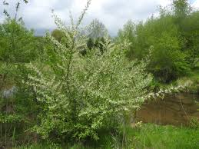
Autumn Olive (Elaeagnus umbellata) is capable of fixing nitrogen in its roots, so it can grow on bare mineral substrates. This may sound appealing but it threatens native ecosystems by out-competing and displacing native plant species, creating dense shade and interfering with natural plant succession and nutrient cycling. Plant Grounsel Tree (Baccharis spp.) instead, which is an excellent pollinator plant or the beautiful fringetree (Chionanthus virginicus).
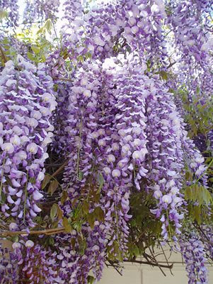

Chinese Wisteria (Wisteria sinensis) can displace native vegetation and kill trees and shrubs by girdling them. The vine can change the structure of a forest by killing trees and altering the light availability to the forest floor. Plant instead Clematis spp. or the American native variety (which tends to not be as showy) Wisteria sinensis.

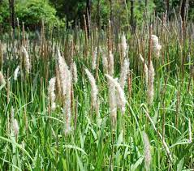

Cogongrass (Imperata cylindrica) has earned the title of the worst invasive species in the world. Yet occasionally it still slips into landscape plans! Plant instead native Muhly grass (Muhlenbergia capillaris) which has a beautiful pink hue.

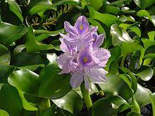

Common water hyacinth (Eichhornia crassipes) is a terrible bane of the Ogeechee River and was not present historically but a recent hurricane flooded one man’s yard upriver who had a pond that held water hyacinth. It took only a few months to float its way to Coastal Georgia . Floating plants to consider include Pickerelweed (Pontederia cordata), Golden Clubs, or Water lily spp.
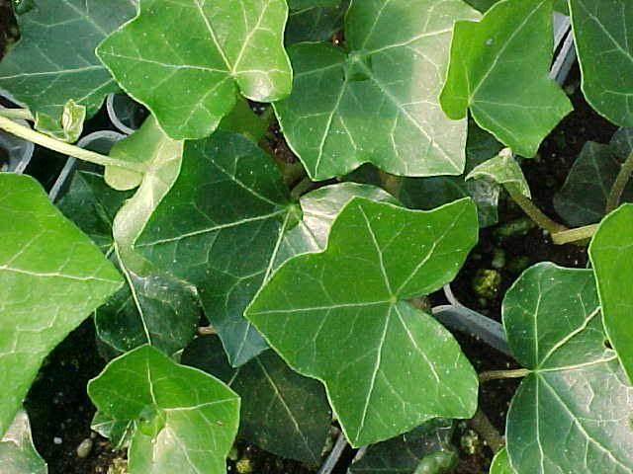

English Ivy (Hedera helix) is a nonnative climbing vine that spreads quickly and can cause extensive damage to local tree species by engulfing branches and essentially suffocating the tree. Plant pollinator powerhouses Crossvine (Bignonia capreolata) or Carolina Jessamine ( Gelsemium sempervirens) instead, as both have lovely yellow flowers as well as wide leaves.

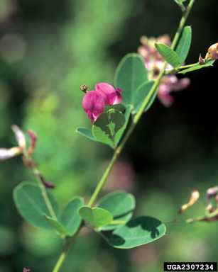

Shrubby Lespedeza (Lespedeza bicolor) was once planted for wildlife food, only to find it didn’t quite make the cut for native animals and began spreading into the forest understory, displacing native plants. Alternatives include Sumac spp. and Wax Myrtle (Myrica cerifera)

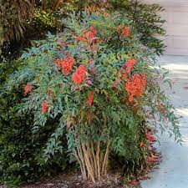
Nandina (Nandina domestica) also known as Heavenly Bamboo is a plant that causes a lot of issues for a popular bird of coastal Georgia, the Cedar Waxwing. The berries are toxic and can easily kill unsuspecting Cedar Waxwings who ingest berry heavy diets during their winter stay here. Plant ButtonBush (Cephalanthus occidentalis) in damper soil conditions or American Beautyberry (Callicarpa americana) in drier soils. Yaupon Holly (Ilex vomitoria) is also an excellent native alternative as it has similar red berries.

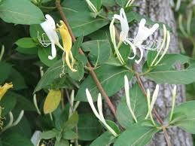

Japanese Honeysuckle (Lonicera japonica and Lonicera flava) is a popular vine here but is actually an invasive weed! It displaces the native and very good pollinator plant, Coral Honeysuckle (Lonicera sempervirens). Plant either the Coral Honeysuckle or a butterfly favorite- Maypop vine (Passiflora incarnata).

See Page 48 for a complete list of Native Pollinator Plants Recommended for The Georgia Coast.

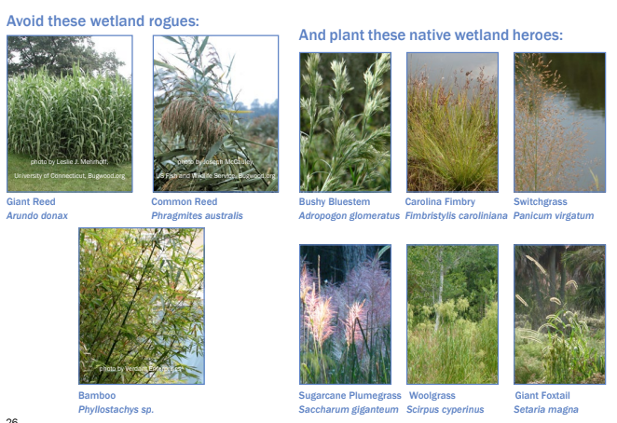
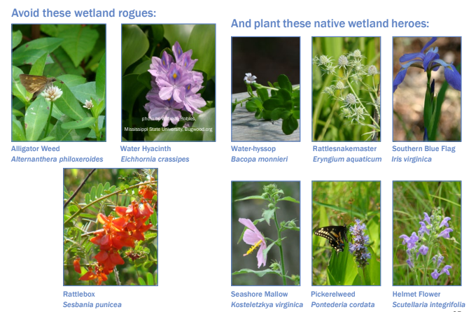
Other Plants to monitor for and their alternatives: (taken from A Maintenance Guide for Constructed Wetlands of the Southern Coastal Plain)

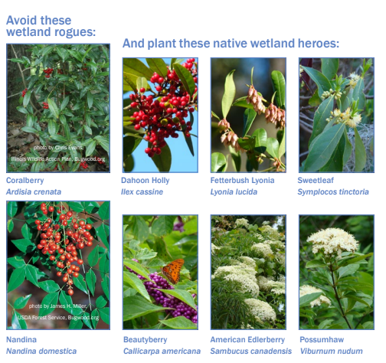
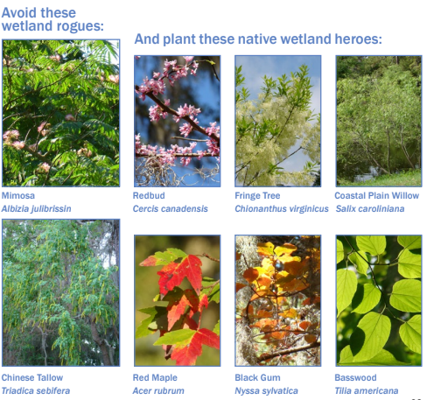
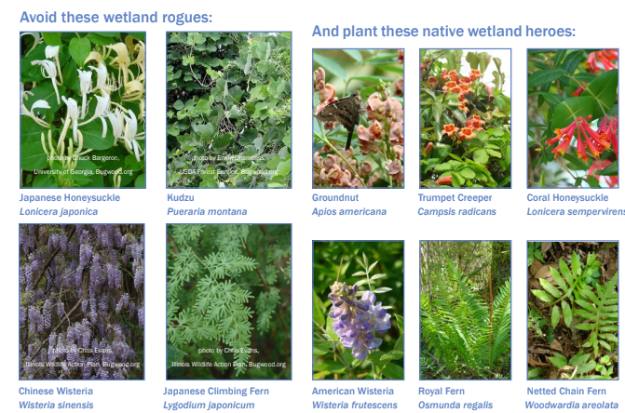

Herbicide Usage and Invasive Plants
Herbicides are chemicals that control or kill undesirable plants. Herbicides can be expensive, but they are cost effective when used properly, particularly against invasive species. It is important to weigh the risks and benefits of utilizing herbicides and select the least-toxic option necessary for the problem being addressed and ONLY apply according to package directions!
Herbicides are the only effective way to combat certain non-native, invasive plants that are serious problems in native habitats including:
1. Chinese tallow tree
2. Japanese climbing fern
3. Privet (two species)
4. Turf-forming grasses (primarily bahiagrass and bermudagrass).

Tallow trees and privet are dispersed by birds and wind. Without the use of herbicides, a tallow tree that is cut down will sprout a newgroup of trees quickly. Japanese climbing fern invades through airborne spores. Turf grasses often originate from roadsides or pastures. They tend to regenerate very quickly when just chopped down, even to the base, without the follow-up use of herbicides.

Herbicides are applied in different ways. The most effective method for small plants is to spray the leaves in late summer when the plant is transporting sugars from the leaves back to the roots. For larger properties, herbicide can be applied cost-effectively to an entire tract of property by using a sprayer mounted on a tractor or ATV. On larger trees, a hatchet is used to hack into the bark and herbicide is sprayed into the cut also called cut-stump application. Your landscaping team should have herbicide certification and should be able to advise you on the best type of herbicide to utilize, especially if you are on or near a water body. Aquatic herbicides are drastically different both in their applications and seasonality (see pond management section). Be cautious if your landscape company only utilizes one type of herbicide or does not utilize aquatic-specific surfactants. Selective herbicides should be used whenever possible and surfactants (things that help the herbicide stick to the plant’s surface) should be used in appropriate mixtures. See references page for more information on herbicide usage specifics.
Controlling the Shrub Layer (i.e.- Lot Clearing)
When hardwood species in a pine forest, such as oaks and sweet gums, become established they often shade out native grasses. This loss of vegetation decreases the wildlife value of the habitat and reduces the ability of the forest to burn. While many communities are weary of using controlled burn (prescribed burn) methods in close proximity to houses, controlled burns are the natural control for many species here in Coastal Georgia. Instead, herbicide applied along with removal of the shrub layer can restore the habitat if controlled burning is not available or too risky.
Following a timber harvest, the shrub layer can proliferate, often shading out native grasses and forbs. When this occurs, these areas are mowed down and often sprayed with a selective herbicide that kills the shrubs but not the grasses. After one year’s application the shrub growth can be controlled in future years with a regular schedule of maintenance.
Problems occur when this is done incorrectly. Timing is vital when clearing lots and maintaining the health of the entire communities’ property, with particular focus on wildlife. Clearing lands should be done after late summer, preferably in early winter. This minimizes the impact on nesting wildlife, who can not only be killed by brush hogs, but also can be scared away from nesting sites, causing abandoned babies to either starve to death or be easily picked off by predators. Herbicide should only be applied when temperatures are conducive to the plant taking up the herbicide, so winter sprays are not recommended. The best course can be to remove brush in winter, then spray in early spring using a selective herbicide that will not disperse into the air.
Issues also arise when neighborhood lots are cleared without reference to other clearings occurring in the same area. Wildlife need time to move on to other areas for foraging and food sources, particularly in the winter. Mass clearings cause pushing of wildlife in small concentrated areas, often onto existing homeowners property such as raccoons in dumpster foraging for food or deer browsing heavily on flowering bushes. Making sure you are clearing your lot in sequence with other clearings in the same area, not at the same time. This will help reduce wildlife conflicts both on your property and your neighbors! Contact your POA to see when lots are scheduled for clearing and make sure that no more than 2 lots are scheduled for clearing on the same week on the same general area of property (i.e.- Clearing 2 lots in the same neighborhood is fine as enough distance is present between them to satisfy wildlife’s ability to relocate).

Lake Bank and Pond Management
Vista Pruning
The objective of vista pruning is to provide attractive views from the main rooms on the first floor of a house while maintaining a filtered view of the home from marshes, ponds, trails or the golf course. Pruning in the buffer area should leave vegetation of varying heights and types (trees, shrubs, aquatic plants) so a hedge-like appearance is not created.
Marsh Views
Marshes are delicate wetland habitats that must be protected from runoff by maintaining a thick vegetative buffer. Pruning for view vistas in the buffer area should leave vegetation of varying heights and lawns of just grass should not be located up to a view of a marsh edge.
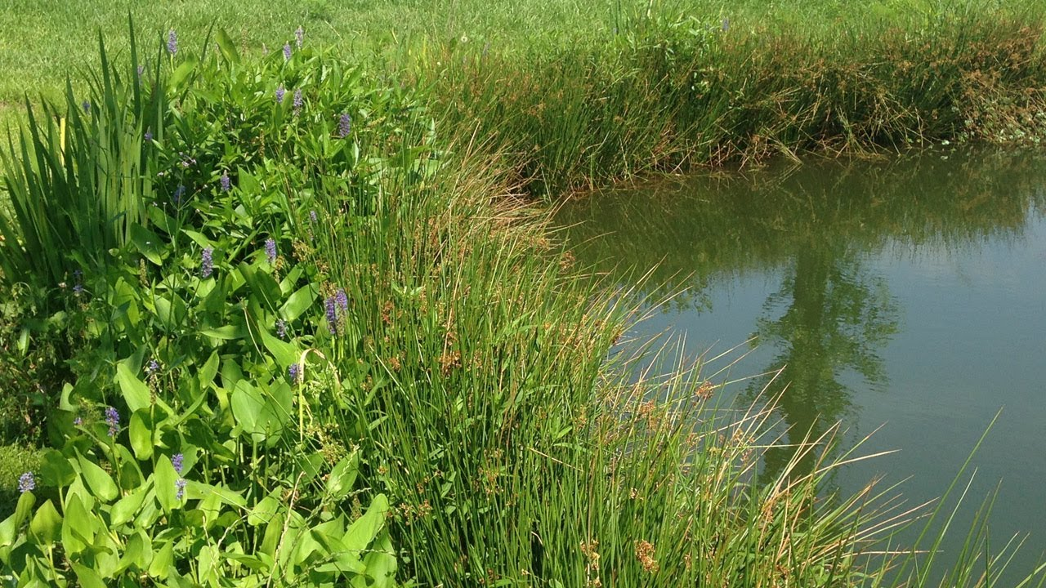
Lake Vistas
Pruning to achieve views to a pond must be done with wildlife and pond edge erosion in mind. It’s a good idea to maintain a variety of vegetation types and heights along a pond edge. Maintaining taller vegetation along pond edges also discourages alligators from basking in those spots! The importance of planting along a lake’s edge correctly can not be overstated!

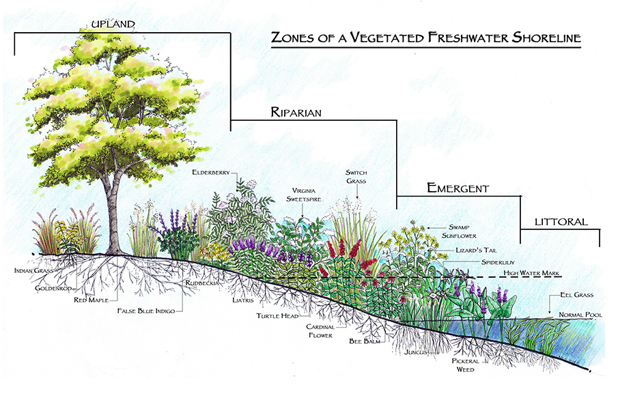

Erosion Control
A living shoreline that descends past the waterline is essential to preventing erosion issues and minimizing negative flow of nutrients! A properly constructed lake bank should focus on all areas of the waterline. You should plant low height plants in order to provide the best view of the water, but having grass run to the edge of the lake bank is NOT RECOMMENDED. Grass has too small a root system to provide proper erosion control and therefore plantings at edges of the lakes are key to holding in the soil. Core logs may be needed in areas where erosion has already occurred. Planting wildflowers and other vegetation on core logs is recommended. Littoral shelves can also be utilized for this (see photo on page 18 and planting list on page 89).
For more information about saltwater living shorelines, please visit coastalgadnr.org/LivingShorelines or contact the Coastal Resource Division of the GA DNR. There are contractors who have been trained through CRD and can help assist you as well.

Habitat & Species Diversification
The natural processes taking place in wetlands and water banks create a unique habitat that attracts a diverse cast of flora, fauna and microorganisms—a significant number of which can only survive in this specialized environment. Many species native to the Southern Coastal Plain thrive in constructed wetland areas with proper landscaping
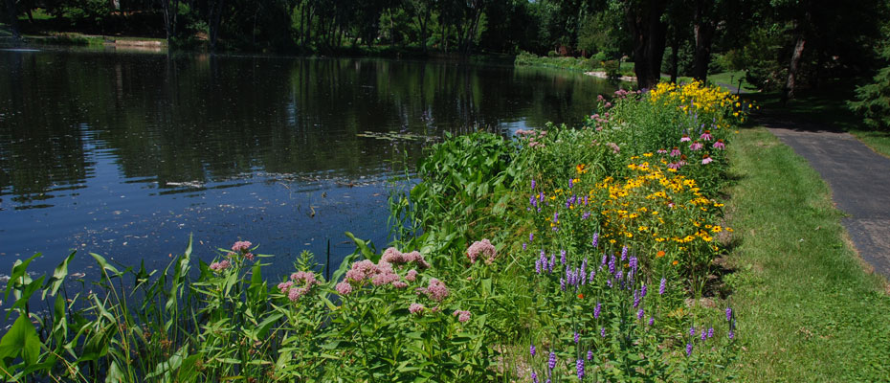

Alligator Prevention
Having an area of higher brush along your shoreline not only creates beneficial habitat for animals, it also can discourage animals from coming up into your yard, particularly the American Alligator. Alligators like to bask on open areas along the banks, so yards with grass only banks are inviting alligators up to rest. This can create issues with pets and children. Giving alligators a small patch of grassed land off to the side of your yard where pets and children will not go, then creating a barrier of taller grasses and plants prevents the alligators from coming into your yard, but still gives you the opportunity to view them from a comfortable vantage point. Please see page 24 for more information on barrier planting. See page 46 for more information about Alligators.

Caring for a Newly Constructed Bank
During the first growing season, provide temporary irrigation and inspect vegetation every 2 to 3 weeks.
During the first two years, inspect the constructed wetland at least quarterly and after any major storm event (more than 2 inches in 24 hours). Inspections should assess the following factors, and problems should be corrected as soon as possible:
• Vegetation
• Erosion
• Bank stability
• Sediment and debris accumulation
During the first three years, vegetation will require watering, weeding, mulching, and possibly replanting. Exotic invasive species should be removed and may need to be replaced with desirable native plants.

General Management Considerations
Once established, living shorelines should be relatively low-maintenance landscapes, but they greatly benefit from a designed management plan. The management plan should both maximize ecological function and also maintain aesthetics.

Following Major Storm Events
Erosion and bank stability - Inspect banks for settlement, erosion, scouring, cracking, sloughing, seepage, and rilling. Remove new woody vegetation growth to avoid root damage to banks.
Littoral zones - Remove exotic invasive plant species such as Water Hyacinth (Eichhornia crassipes) and Alligator Weed (Alternanthera philoxeroides) and ensure at least 85% vegetated cover in the emergent vegetation zone.
Soil - Inspect for loss of soil on wetland banks due to erosion. If plants are struggling it may be necessary to apply soil amendments.

Ephemeral wetlands
Ephemeral wetlands are temporary wetlands that hold water for part of the year. These wetlands may be shallow impoundments, ditches or low spots in the forest. They are critically important for a variety of wildlife species like wood ducks, rusty blackbirds, and many wading bird species.
These are productive habitats for breeding amphibians such as bullfrogs, leopard frogs, newts and mole salamanders. Adult amphibians lay eggs in the water that develop into aquatic larvae. The larvae undergo metamorphosis and transform into adult forms before the pond dries. Because the wetlands dry annually, predatory fish such as bass and bream do not survive. However, mosquito fish (Gambusia), which eat larval mosquitoes, are usually present. If you have a wetland on your property, consider using environmentally safe mosquito dunks with Bacillus bacteria to control mosquitoes, but natural predators will eventually colonize and effectively control mosquitoes in most circumstances.
Contrary to popular belief, ephemeral wetlands typically aid in the control of mosquitoes, not create more mosquitoes!
Ephemeral wetlands may be home to a variety of interesting dragonfly and damselfly species, including comet darners, roseate skimmers, Needham’s skimmers and many others. These important predaceous insects feed on a variety of pest species like mosquitoes, deer flies and horseflies, so providing suitable habitat for them is a great benefit.
Ephemeral wetland habitat can also be beneficial for many different types of nesting birds. Wood duck boxes scattered around these wetlands can be beneficial to monitor for nesting ducks. Wood duck nesting boxes are easy to build and install and can help with pond management since many wood ducks will act as natural pest and algae control. Wood ducks nest in these boxes from late winter through early summer and prefer boxes 4-6 above the water and at least 25% open water near the box. Other animals, such as screech owls, also use the boxes for shelter.

Wildlife Management

Pollinator Gardens
Providing a pollinator garden in your yard can be not only aesthetically pleasing, but can also provide assistance to the health of many different plants across The Coastal Ga property! Birds, bats, bees, butterflies, beetles, and other small mammals that pollinate plants are responsible for bringing us one out of every three bites of food we eat! They also sustain our ecosystems and produce our natural resources by helping plants reproduce.
Pollinating animals travel from plant to plant carrying pollen on their bodies in a vital interaction that allows the transfer of genetic material critical to the reproductive system of most flowering plants – the very plants that:
- bring us countless fruits, vegetables, and nuts,
- ½ of the world’s oils, fibers and raw materials;
- prevent soil erosion,
- and increase carbon sequestration
This nearly invisible ecosystem service is a precious resource that requires attention and support. By planting pollinator attracting plants, you can assist these animals through either providing food, habitat, or in some cases like the Monarch Butterfly, host plants for their reproductive success. Planting native plants is always recommended as many of these are pollinator attractants. For native plant guide see page 48.

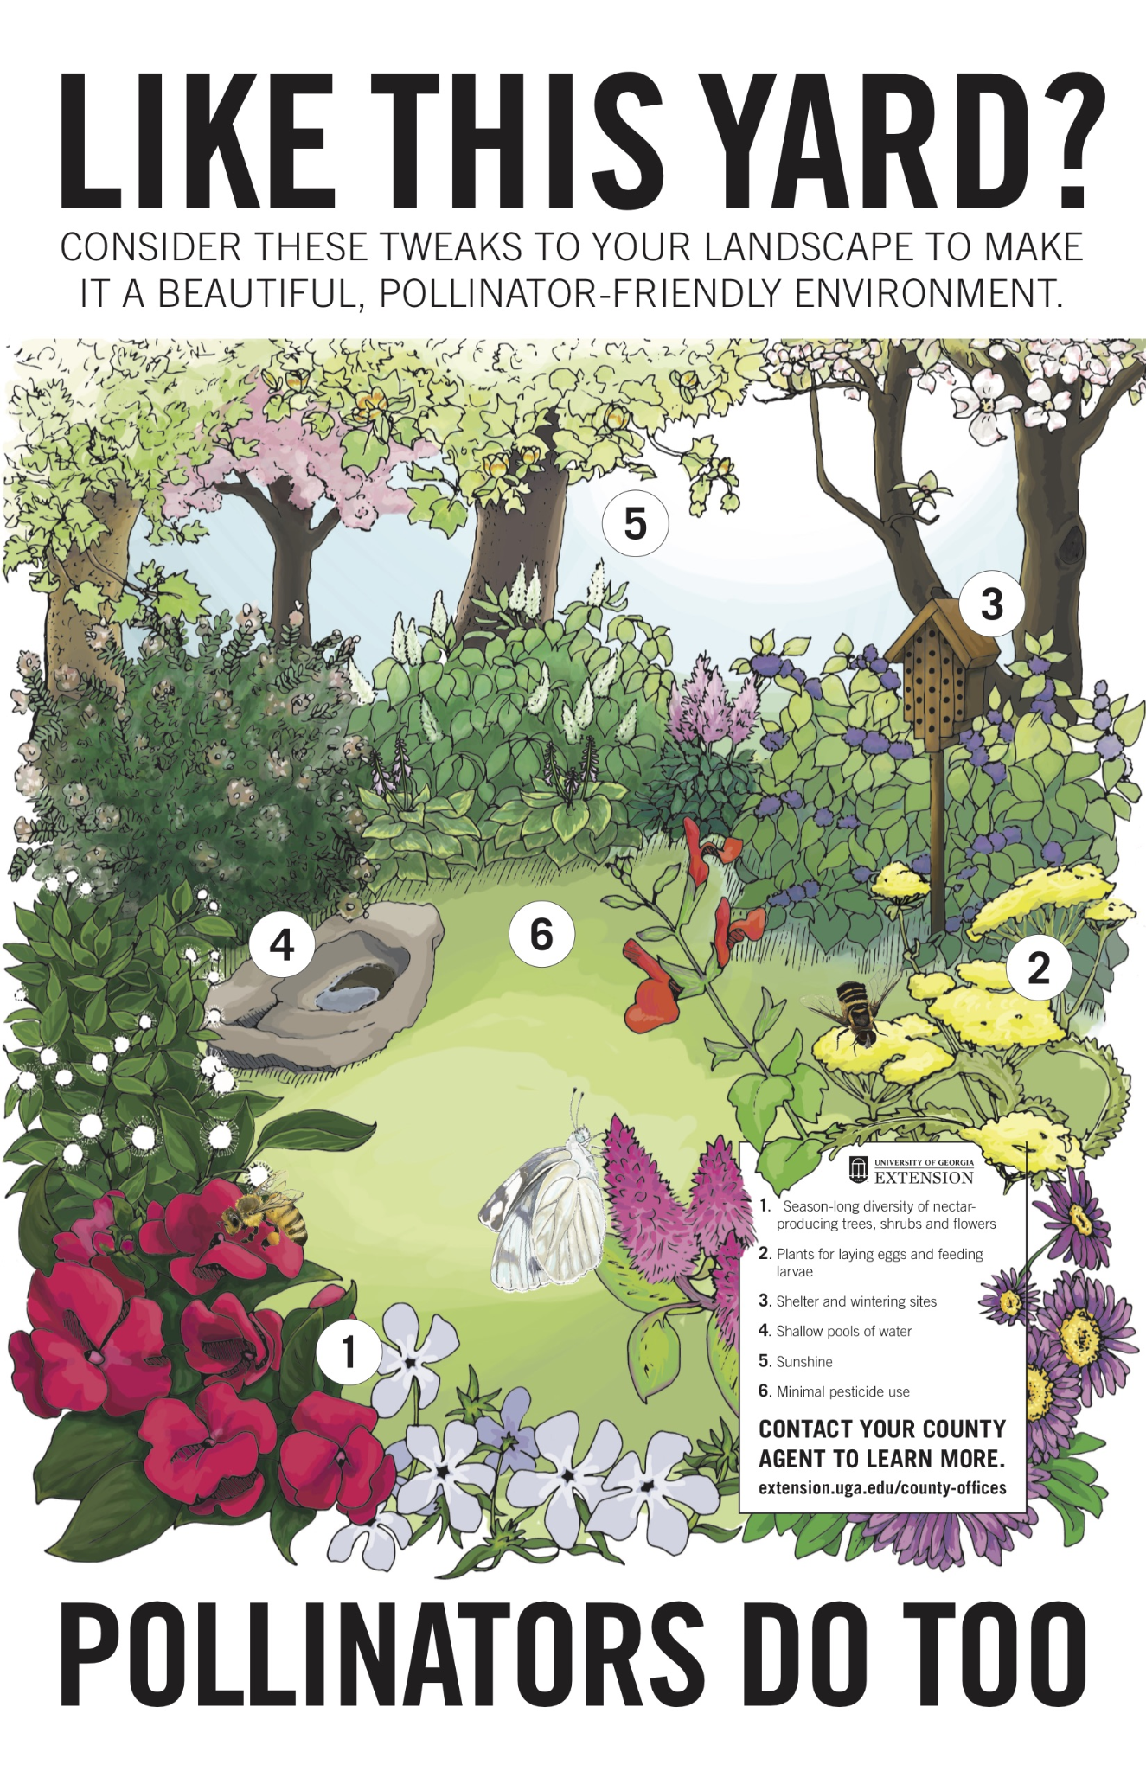
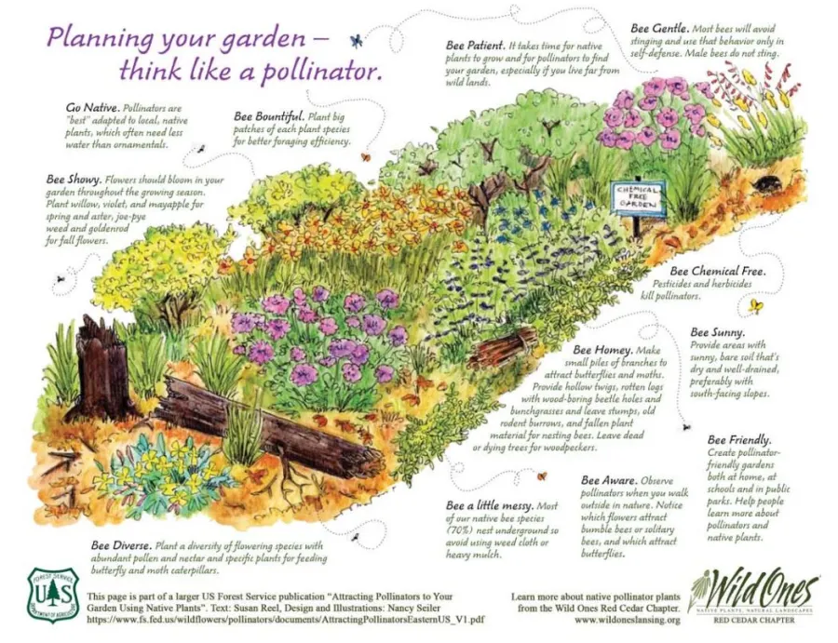
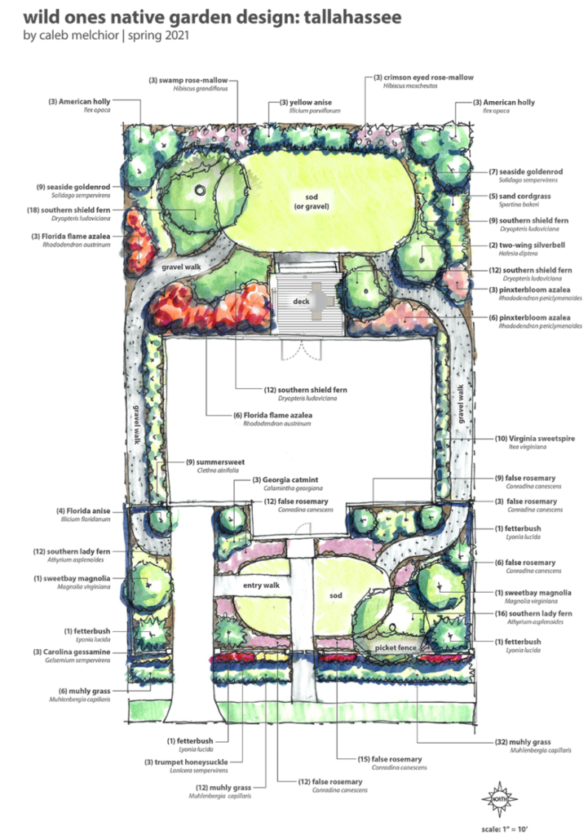
Zoning with Barrier Planting and Why Landscaping Layout is Vital to Yard Sustainability
Zoning is placing desirable browse plants like azaleas and gardenias in areas where they are less likely to become victims of wildlife like deer. This strategy is particularly effective when used with barrier plants. There are many uses for barrier plants. People living on corner properties may want to erect sight and access barriers. Some types of barrier plants can restrict pests and predators from accessing a property. The proper layout of these barrier plants can be key to the success of your yard and what you wish to achieve. The following landscape plan is recommended to prevent browse on your protected plants:
- Perimeter Plants: Edibles you want eaten by the wildlife. Plants include: persimmon trees, pecan trees, white oaks, clover, etc.
- Barrier Plants: Inedibles or plants known to offend planted in between the perimeter and protected plants will help deter animals like deer from continuing on to the protected plants and stay at the perimeter offerings. Plants that are resistant to wildlife are typically fragrant foliage like Bee Balm*, Salvias*, Daffodils*, Zinnas*, Foxgloves, Black eyed susans* (sometimes will eat but not often!), Onion and garlic including society garlic, Marigolds*, Ferns (great for shady yard), and Inkberry hedges*.
*Many of these plants have the added benefit of being pollinator plants!
- Protected Plants: Flowering plants you want for display or pollination always planted closest to the house such as azaleas, roses, gardenias, etc.

Wildlife is wild, so they may not necessarily abide by these guidelines, but zone planting is a good practice to have in your yard’s landscaping.

Nuisance Animals and Human-Wildlife Conflict Resolution

NEVER FEED WILDLIFE, YOU ARE NOT DOING THEM A FAVOR, YOU ARE ACCLIMATING THEM TO APPROACHING PEOPLE AND THEREFORE ENDANGERING THEIR LIVES. This can not be stressed enough and is the #1 rule of community wildlife management. Please do not feed wildlife, and inform anyone you see doing so that it is against GA law, the rules of your community and comes with a serious fine. Animals who are fed can be deemed nuisance animals and can be killed because of your actions!
Bird feeders are an exception, as are domesticated non-migratory ducks (outside of the pond area) due to the limited interaction liability. All feeders must be cleaned regularly (bi-weekly in some cases) to prevent the spread of disease! All neighborhood bird feeders, bird baths, and bird houses should be dismantled and thoroughly cleaned in bleach solution at the end of the birding season (dependent on species).
Ducks and geese should never be fed, but especially in pond waters as it can encourage bacterial growth and the spread of disease. Canada geese and migratory waterfowl (Outside of domesticated ducks, with most mallards being domesticated ducks brought to communities by developers for aesthetic purposes.) should not be fed as it can prevent migration and further human-wildlife conflict. Bread is dangerous for waterfowl as it can cause malnutrition and has the potential to carry mold spores which are extremely toxic to birds.
To learn more about how to correctly feed neighborhood birds, please see the habitat enhancement section.
Fish feeders are also acceptable as long as it is done at the appropriate amount, location, and time of year. Excessive fish food will cause a pond to quickly turn over due to excessive nutrients and can cause mass kills of fish.

Snakes
Snakes can be found in almost every habitat and are an important part of the biodiversity of the Georgia Coast.They are valuable members of the food chain, serving as both predators and prey. They can also serve as indicators of habitat quality. Most of our species are non-venomous and are harmless to people and pets. In Georgia, of the 46 total species of snakes, only 6 are venomous! In fact, it is against GA law to kill non-venomous snakes and you can expect a hefty fine if caught.
Snake bites are very unusual and typically occur when people are walking in leafy areas wearing sandals, picking up wood without first looking under it, or intentionally harassing snakes. In the highly unlikely event that you are bitten by a venomous snake, call 911 or have someone drive you to the hospital. Do not try to catch or kill the snake. Do not attempt to apply a tourniquet, make incisions or suck the poison out of the wound. These actions likely will make your condition worse. Copperhead and cottonmouth venom is not deadly to non-immune compromised humans with proper treatment but it can be painful.
If a venomous snake bites your dog, immediately call your vet. Most dogs survive snakebites with proper medical treatment. It is encouraged that you actively monitor your dogs when you let them out in your yard. You can properly train your dogs to not seek out/attack snakes by working with fake snake toys and “Leave it” commands.
Snakes help to keep the mice population in balance and will likely move on when the prey population is diminished. They do not ‘den’ and will not choose to be around humans if possible. Sometimes a snake can wander accidentally into a home, especially given their unique ability to squeeze themselves in tight spaces. Call DNR or your local pest control company if you can not determine if the snake is venomous or not.
Remember, no snake wants to bite you! They need that venom to eat, and when they use it for defense, they then have to waste that energy to make more, which in some cases can cause them to become severely depleted of energy reserves. If you come across a snake, slowly retreat and give the snake a few minutes to get away from the area. If it is still present, call your naturalist, security or a designated relocator to properly relocate the snake for you. To find a GA DNR liscenced removal specialist, please visit https://georgiawildlife.com/preventing-wildlife-conflicts. To minimize the risk of being startled or bitten by a snake, be cautious when gardening or moving firewood from stacked piles. Keep pathways around your house clean so you can see cryptically colored snakes. Wear shoes when walking outside.
Do not put mothballs outside as snake deterrents! Not only does this not really work, it can cause the chemicals to seep into the soil and impact your plants on your property. To prevent snakes from being in your yard, clear brush piles and areas of logs and yard debris like high pinestraw patches and leaf litter. Bushes and hedges do not encourage snakes, but they do however, provide habitat to birds that snakes may prey upon.

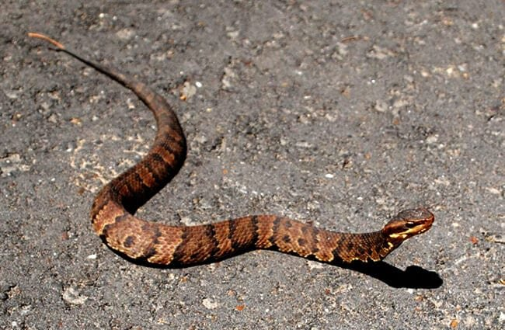
Cottonmouths or Water Moccasins are thick bodied snakes that have a white mouth and will typically show it if threatened. They prefer wetlands and lake banks, versus copperheads which are typically found in wooded areas.

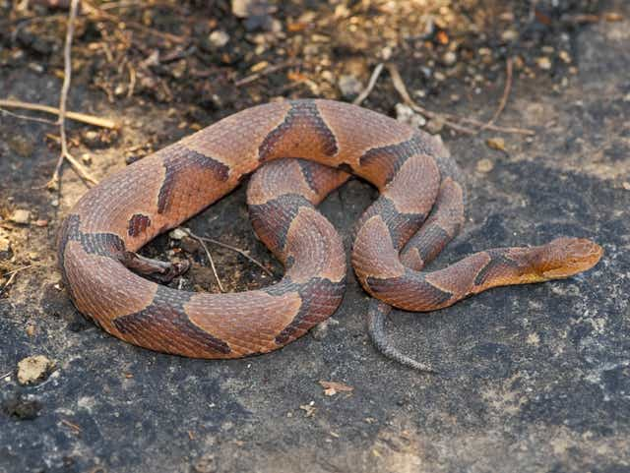

Copperheads have reddish hourglass shaped bands along the back and, as their name implies, copper-colored heads.

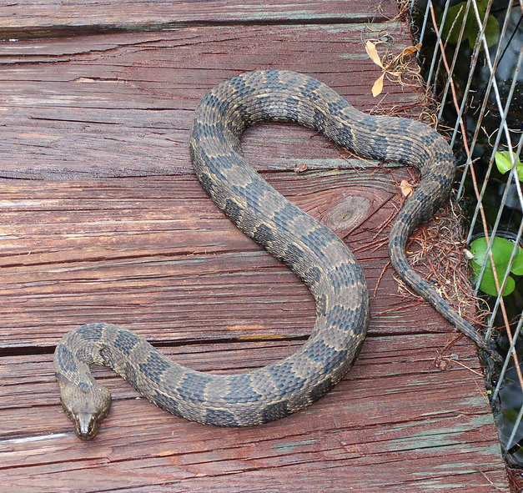

The Banded or Brown Water Snakes are harmless and beneficial snakes that are commonly mistaken for a cottonmouth due to their large jaws, which they use to catch frogs.

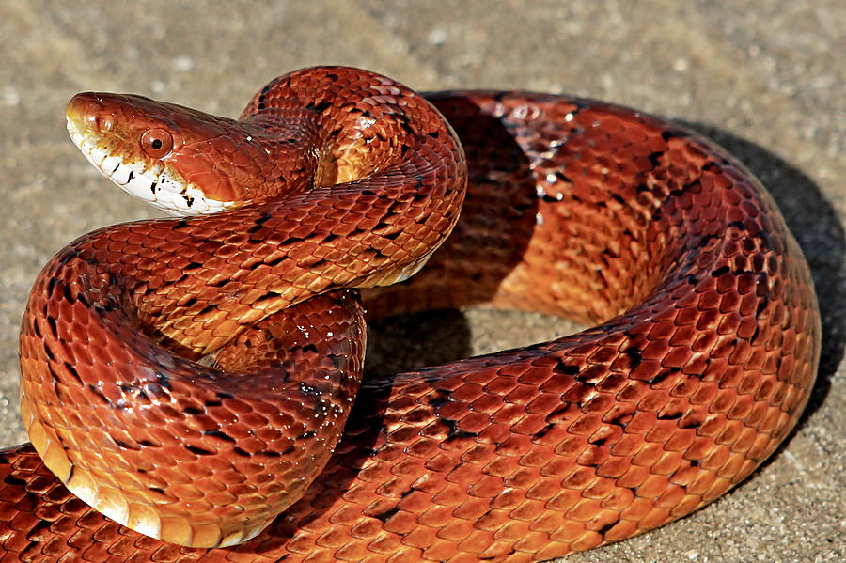

The Red Rat Snake, or Corn Snake, is common in Coastal Ga and often mistaken for the copperhead. These are very beneficial and docile snakes, so please do not harm them!
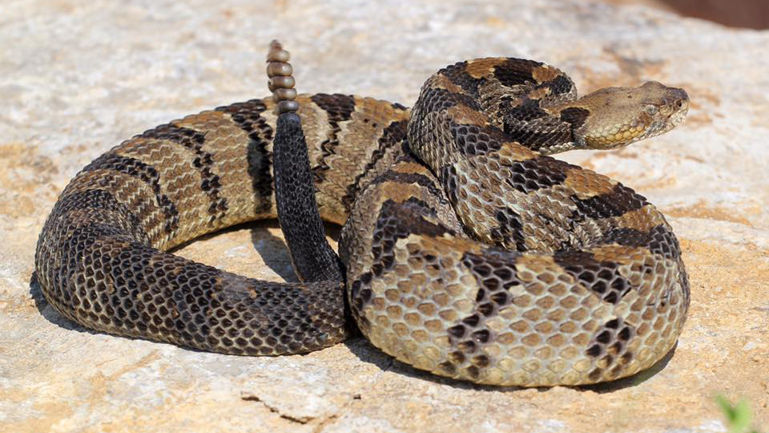
A rattle or button on the end of the tail is an easy way to distinguish the three rattlesnake species from other snakes. The Canebrake Rattlesnake or Timber Rattlesnake is a medium sized snake. There are several color variations, but all individuals have wavy cross-bands along the back. Most individuals have a reddish-brown stripe down the spine.

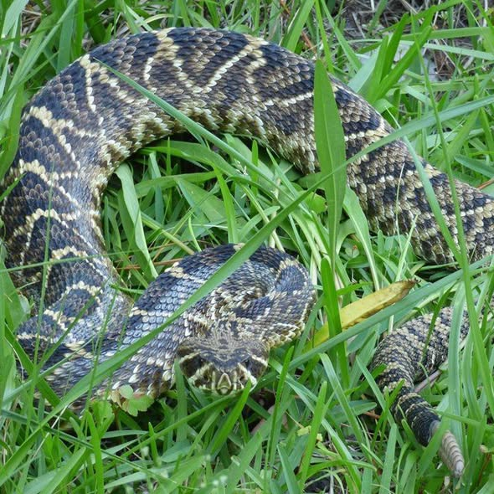
The Eastern Diamondback Rattlesnake is the largest rattlesnake in the United States.. It is a heavy-bodied snake with a distinct diamond shape pattern along the back.

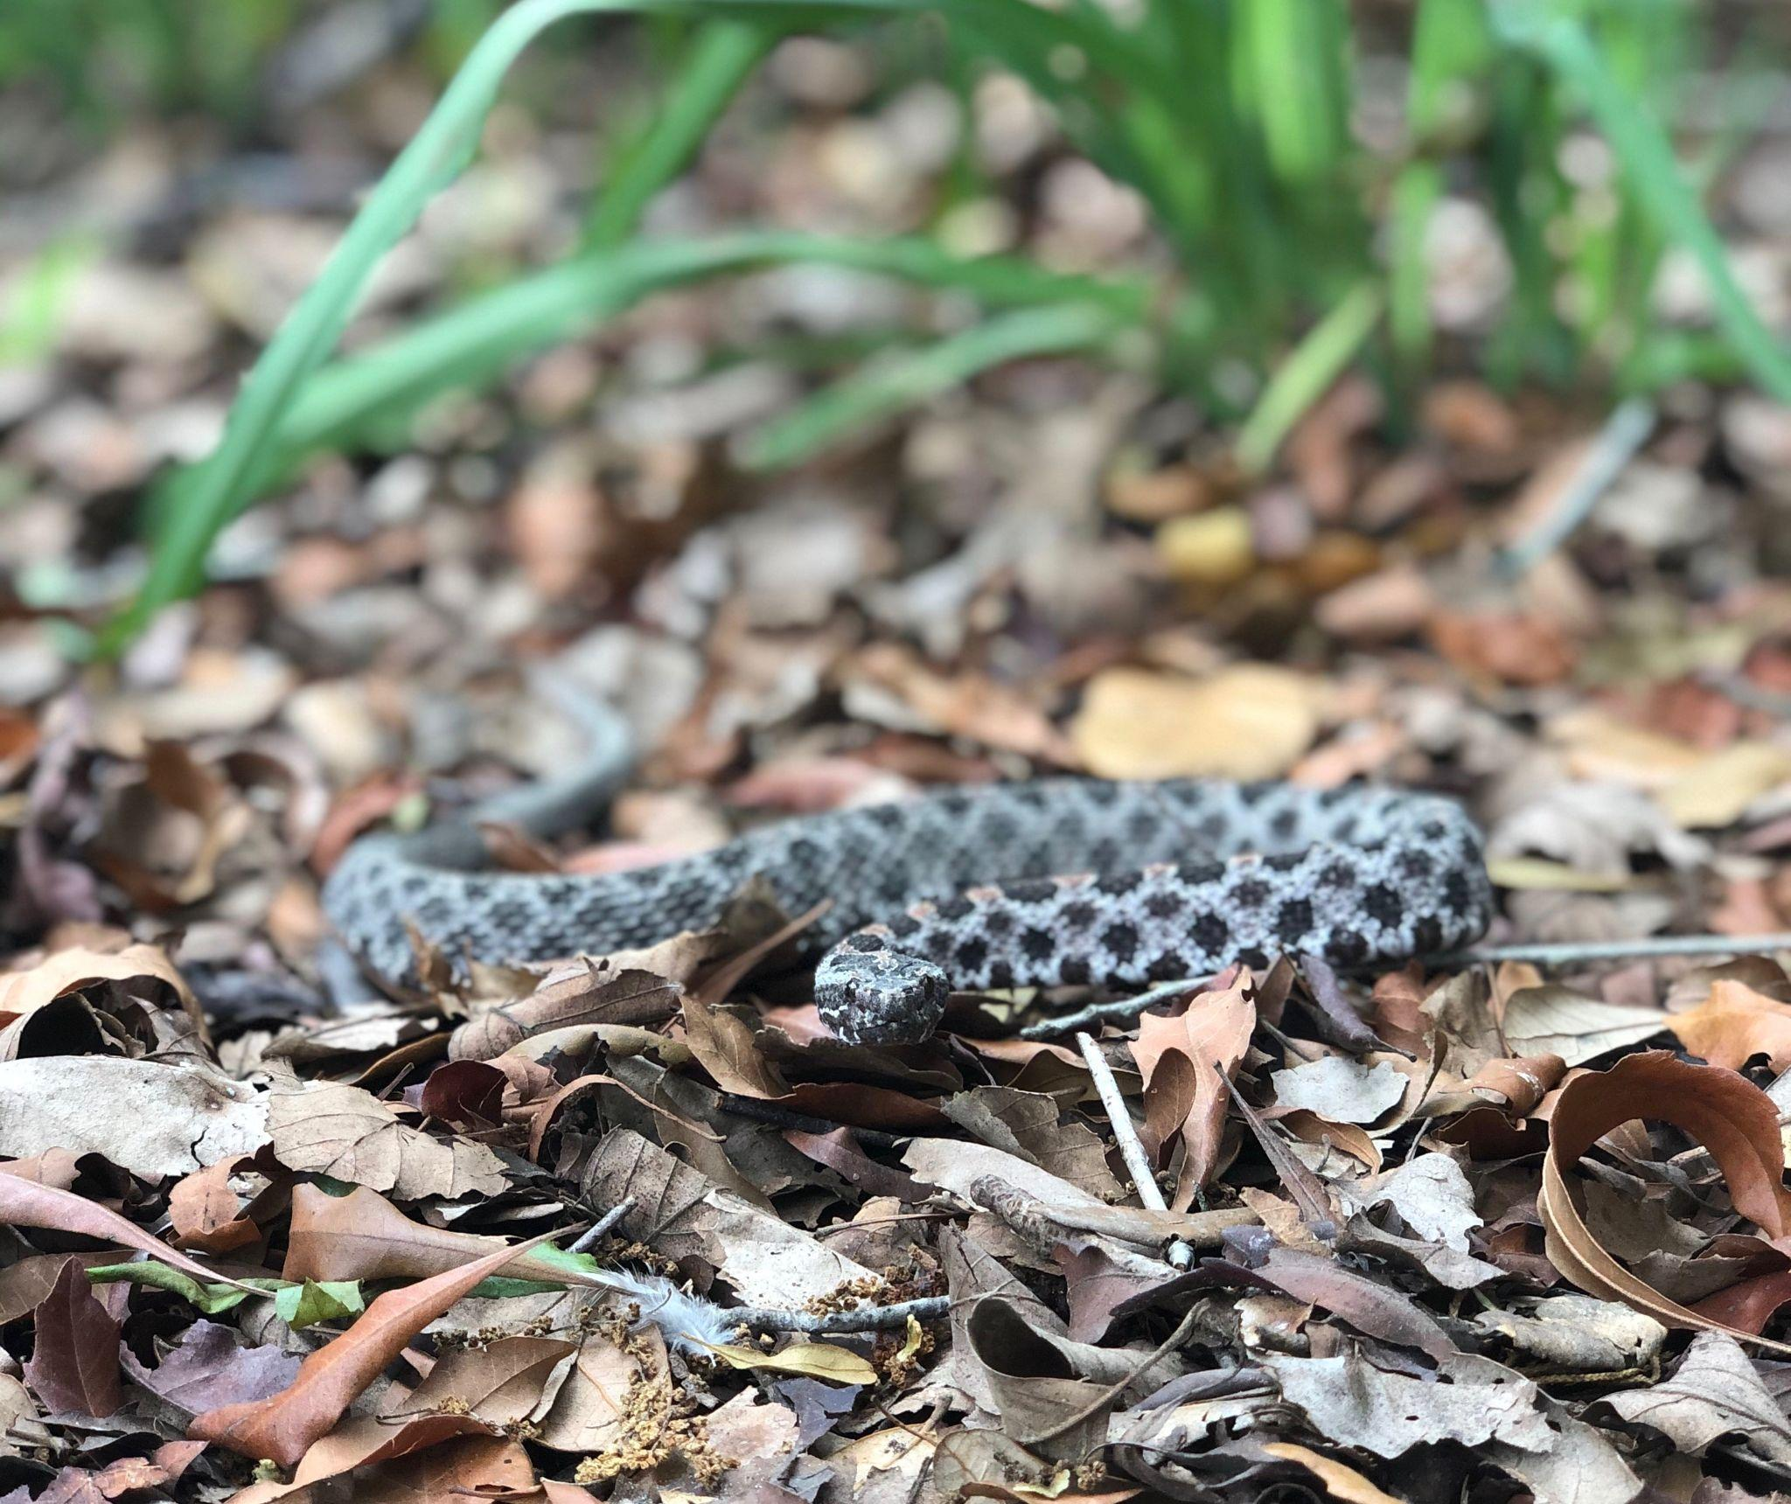
The smallest rattlesnake in the US, the Pygmy Rattlesnake is greyish in color with a distinctive pattern.

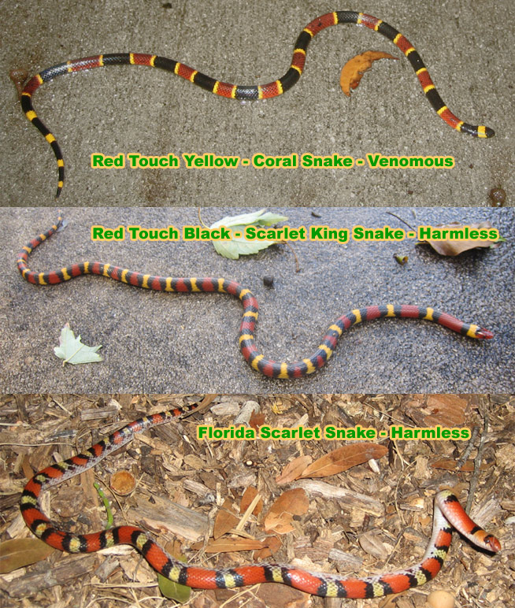

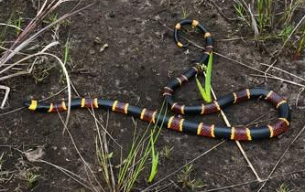
The Eastern Coral Snake (Micrurus fulvius) is a highly venomous, slender, and brightly colored snake found in the southeastern United States. It is known for its red, yellow, and black bands that completely circle its body, with the red bands touching the yellow bands. It has several look alikes but an easy way to remember is “Red Touches Yellow, Will Kill A Fellow. Red Touches Black is a Friend of Jack”.
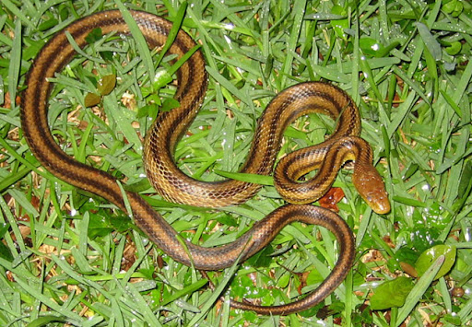
The Yellow Rat Snake is very common at Coastal Ga and is completely harmless. They are typically very docile and will move quickly if bothered. They are very thin and long with stripes down the length of the body.
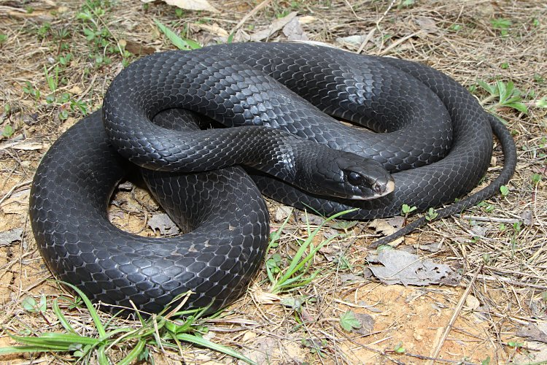
Back Racers are very fast moving black snakes common to the golf course here at The Coastal Ga. Although they are harmless, do not attempt to pick one up or harass one as they can bite very hard!

Rodents
Rodents are a group of mammals that include mice, rats, and squirrels. There are many species native to the region and they play an important role in ecosystem dynamics as prey for larger predators such as bobcats, raptors, and foxes. They also disperse seeds of native plants. Mice and rats, particularly non-natives – such as the house mouse, black rat, and Norway rat – may be unwanted pests in and around the home. They can chew on electrical wires, damage gardens, and property, and occasionally carry diseases.

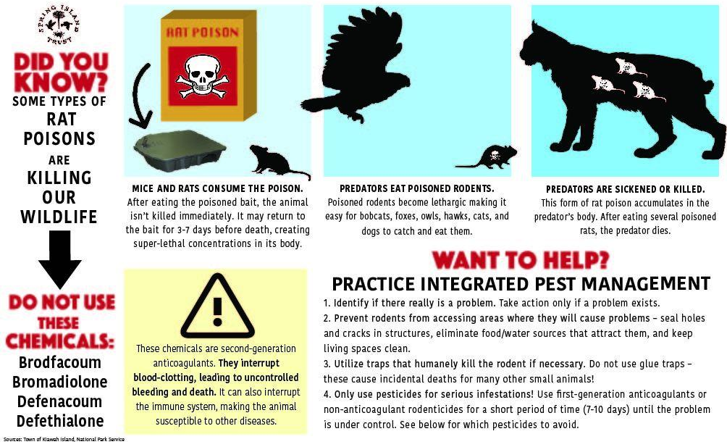
It is important to know that some rodent control measures can be highly detrimental to native wildlife!

CLICK TO

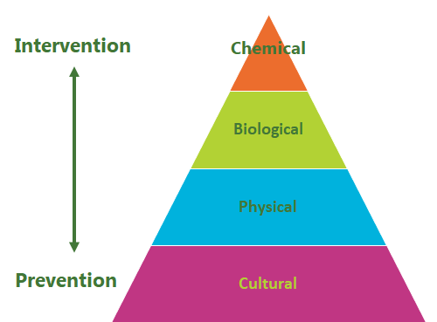
Practice Integrated Pest Management
- Identify if there really is a problem. Take action only if a problem exists.
- Prevent rodents from accessing areas where they will cause problems – seal holes and cracks in structures, eliminate food/water sources that attract them, and keep living spaces clean.
- Utilize traps that humanely kill the rodent if necessary. Do not use glue traps – these cause accidental deaths for many other small animals and birds!
- Only use pesticides for serious infestations! Use first-generation anticoagulants or non-anticoagulant rodenticides for a short period of time (7-10 days) until the problem is under control. See below for which pesticides to avoid.

What are second-generation anticoagulant rodenticides (SGAs)?

These include Brodifacoum, Bromadiolone, Difenacoum, and Difethialone. Do not use these chemicals!!!
The pesticides are highly toxic and work over a long period of time. They are often applied in bait stations – the mouse or rat eats the bait but is not killed immediately. The animal may return to the bait for 3-7 days before succumbing to the poison, allowing super-lethal concentrations to build up in its body. The poisoned rodents become lethargic and bobcats, foxes, owls, hawks, cats, and dogs then easily catch and eat these poisoned rodents. Because the toxins can persist in the body for up to one year, the predator may eventually receive a lethal dose of the poison and die.
The Town of Kiawah Island had experienced almost a 70% decline in its once-healthy bobcat population, and SGAs were eventually identified as the culprit. The systematic recovery of the predator-prey cycle has cost them a lot of money and effort to keep the population of prey species down as a result. Essentially- using SGAs INCREASED the rodent problem since it reduced the natural predators. We do not want this to happen to our bobcats, raptors, and other wildlife!
Possums
Virginia Opossums are small to medium sized marsupials that are very important to the ecosystem of coastal Georgia.. Many mistakenly believe that possums are aggressive, since they will open their mouths to show their teeth when they are approached. This is a defense mechanism and they very rarely bite or are aggressive. Possums have poor eyesight and often are surprised by people. They are purely nocturnal and have much better eyesight at night.
They are mistaken for armadillos who will dig up yards, or raccoons that will get into your trash but possums are rarely an issue. Although a true omnivore and will eat just about anything offered, possums are less likely to go through trash or seek out urban areas and human interaction like a raccoon. Possums are vivacious insect eaters instead and can eat their weight in ticks in one night! They are very good for removing pests from your garden like slugs and ants and even small mammals that can cause human diseases and infections! Possums are also immune to snake venom and will often rid the landscape of small venomous snakes, thus making them a welcome addition to any yard!
Possums are the only native marsupials to North America. They tend to have a lower body temperature, and therefore are not considered a vector species of Rabies. There has never been a possum-human transmission of rabies, though if you handle a deceased carcass, the chance of getting the disease leptospirosis does exist. Trapping and removing possums is not recommended for this reason. Most people complain about opossums just being there, rather than for any problems they cause and this is not an appropriate definition of a nuisance animal and is illogical to our ecosystem.
Possums prefer to reside in trees. They will not actively tear up or damage property but occasionally can find existing damage to your home and will not pass up the opportunity to move in. The best way to keep opossums from denning under a deck or patio is to make sure they cannot get there in the first place by keeping any holes filled. If you suspect a mother opossum has already moved in, wait until she leaves her den (two hours after dark is generally a safe time). Then, loosely close the opening with netting, straw or other fibrous material. This will ensure that an animal trapped inside can clear the path to escape, but one outside will not disturb the blockage to get back in. Opossum moms take their kids wherever they go, so there is not much chance that any babies will be left behind. But always check for youngsters before closing the opening. If the hole has not been disturbed for two or three nights, it’s safe to assume that no one is inside and the hole can be properly filled. For permanent exclusion we recommend putting in an "L" footer.
Armadillos
Approximately 20 species of armadillo exist, but the nine-banded armadillo is the only one found in the United States. Armadillo means “little armored one” in Spanish and refers to the presence of bony, armor-like plates covering their body. When startled or scared, these armadillos can jump 4 to 5 feet high in the air. Found throughout the southeastern United States, these digging and burrowing mammals are a nuisance to homeowners as they destroy the landscape in their pursuit of food and shelter. Armadillos are powerful diggers and will burrow under plants in landscape, foundations, and driveways. They are capable of destabilizing tree root systems and building foundations with their tunnels.
Damage from armadillo is generally most pronounced in the summer months as lawns are irrigated. Reducing your soil irrigation can help reduce the impact of armadillos and is a good practice to use either way. Increased irrigation makes the soil easier to dig in and brings invertebrates closer to the surface. Armadillo damage is easy to identify as it is noted by multiple shallow holes (usually up to 6 inches). They will often root similar to pigs, especially in loose mulch. Skunk and squirrel damage can look similar, although it is usually smaller in diameter (less than 4 inches) and shallower (less than 3 inches) than armadillo damage. The armadillo generally digs burrows in forested areas. These burrows are used to rest and avoid predators.
Homeowners should be aware that there is seldom a quick and easy fix to any wildlife damage problem. Often the cost (time and money) of control exceeds the damage caused, and in this particular case, damage is mostly aesthetics or nuisance. Whether the nuisance warrants control is related to the tolerance and preference of the homeowner, so consider this before starting any control measures. Damage to rhizomatous grasses such as Bermudagrass is typically manageable as healthy grass can quickly fill in bare patches. Cool season grasses, such as fescue, are more problematic because the bare patches will need to be reseeded in the fall. Regardless, you may want to fill in the digging with soil and turf. Digging in flower beds likewise will require some smoothing out.
Unfortunately, many homeowners instinctively turn to trapping for armadillos. This is not exactly the best case scenario in our area as the armadillos are nomadic and if you have repeated armadillo intrusion, it is most likely not from just one armadillo, but several passing through your yard in a given time period. This is an indication that your yard may be infested with grubs and need treatment from a yard care professional to remove the reason for the armadillos digging in your yard in the first place. Using specific targeted pesticides will improve not only your yard but also reduce the armadillo intrusion. If trapping becomes the only option, then the armadillo must be humanely euthanized on site, it is not recommended to release elsewhere as it will just come back to the spot it last remembered where it was, which is your yard.
Some topical repellents have been used in our area with success, but again it is up to the homeowner’s commitment to the issue that determines the success. Armadillo-SCRAM is a dried blood formula that has to be continuously scattered around the perimeter of the property every day before dusk to help deter the armadillos from entering the property. After several days of application, the armadillos will typically not enter the area again as the smell of blood has scared them off the area. A similar method explores the use of predators’ urine. This can be a smelly application and is not recommended unless you are not in close proximity to neighbors.
Raccoons
Most adult raccoons weigh 10-20 lbs but some individuals can reach almost 30 lbs! They are true omnivores, feeding on a variety of berries and plants as well as insects, fish, frogs, crayfish and small mammals. Many of our coastal raccoons are marsh specialists that feed on a variety of crabs and fish. Their nimble fingers and monkey-like hands help them capture anything small enough to eat. Raccoons do not actually wash their food like the species name Procyon lotor (“a washer”) implies. They do, however, dip prey in the water to tear them apart and remove the unwanted portions of shell, bone and feathers and assist with digestion since they do not have salivary glands.
Raccoons are considered cute by many, but in reality they are fierce creatures, making a variety of growls and hisses as well as baring vicious-looking teeth. They should not be handled or approached. While primarily nocturnal, our raccoons sometimes feed in the daytime, especially in the winter, when they can be seen foraging at low tide in the salt marsh or when feeding young babies. Do not assume an animal is rabid just because it is out in the daytime!
Raccoons can become serious pests because of their intelligence and the dexterity of their hands. They open cabinet doors, refrigerators and other food caches. They raid trash cans and feed from pets’ bowls. They put up quite a fight if they are so inclined.
The raccoon management approach is that first all attractants should be removed from the area and all possible steps taken before resorting to trapping! Removal of all food in the area, securing trash cans with bands, sealing up doors and windows, and repellents such as cayenne pepper and peppermint oil can all be effective against raccoons. Some, however, can be particularly stubborn and unfortunately can be habituated to people, particularly if someone has been feeding them illegally. NEVER FEED WILDLIFE, YOU ARE NOT DOING THEM A FAVOR, YOU ARE ACCLIMATING THEM TO APPROACHING PEOPLE AND THEREFORE ENDANGERING THEIR LIVES.
Trapping should take place from September 15 – March 15 when they do not have babies back in their den, which is generally a hollow in a tree. Raccoons can be captured using a variety of live-catch traps. If released, they often return to the same spot where they were captured. It is illegal to transport raccoons from one area to another because of the chance that one might also be transporting rabies into that area.

Flying Squirrels

The Southern Flying Squirrel is a diminutive rodent with big saucer-like eyes and is probably the most common mammal never seen by humans in Georgia. It occupies a habitat similar to that of the gray squirrel, yet because it is a nocturnal species, it is not seen as often as the other two. It eats a diet of mostly acorns and lichens like the gray squirrel but is a colonial nester with large extended families living together. It is truly arboreal, gliding from tree to tree on folds of outstretched skin. This ability also makes it easy for a flying squirrel to travel to your house from a neighboring tree. They can occupy attics and interior wall spaces easily if access is provided from a hole in the exterior or enter chimneys without caps. It can not be overstated enough to do regular inspections and repairs of your home to prevent ANY wildlife issues from occurring. Preventative inspections save homeowners a lot of time, effort and money in the long run, particularly with regards to wildlife!
Trim all tree limbs close to your home and consider removing larger trees closer than 15 ft from your home. This is good landscaping practice anyways to prevent rooting damage and possible falling limb damage from rot or storms, but with regards to flying squirrel invasion it can be particularly beneficial.
To remove flying squirrels that have already colonized an area, you should look for the entry hole. If you don't find the entry hole(s), you have almost no chance of solving the problem. Make sure all secondary points of entry are sealed shut with a steel screen, mount either a one-way door or a repeater trap over the main hole, and you'll be able to remove the whole colony in one shot! After you are sure they are all out of your attic, remove the trap and seal that last hole. Finally, you can clean the attic of the flying squirrel waste, and check for damage, such as chewed wires as well.
Using glue traps, bait traps, and other inhumane methods are not recommended as this not only does not solve the issue of how they got in, it also is ineffective since there are usually 10-15 flyers in the house at one time when colonization has occurred. The expense of doing this will accumulate and just installing the repeater trap is not only more humane and more expedient, it also is less costly in the long run.

Squirrels

Like flying squirrels, the Eastern Gray Squirrel can be a nuisance that can get into homes occasionally. The same practice as the flyers should be employed. Most homeowners however, do not complain of the gray squirrels bothering their home, but their bird feeders instead! It is highly recommended that homeowners having issues with squirrels at feeders reduce the amount of ‘waste-feed’ they use in feeders. This can be done by getting rid of birdseed that includes corn or by getting tube feeders instead of platform feeders. You can also install baffles on your bird feeders to prevent squirrels, raccoons, and snakes from accessing the top of the feeder where the birds are. Placing strategic squirrel corn cob feeders or peanut butter feeders specifically for squirrels at the edge of your property, away from your bird feeders is also a good solution to lure them away. These can be purchased on Amazon or locally at Wild Birds Unlimited or Ace Hardware.

Fish Population
Otters, eagles, herons, cormorants, and mink feed on fish in our freshwater ponds. This predation by native species is a natural part of living within a natural ecosystem. Underwater structures provide places for fish to hide, thereby reducing the success of otters and other predators that are hunting them. Increasing your underwater structure by donating your natural Christmas tree in the new year or by recycling limbs to provide new habitat in the middle of your pond can be very beneficial. Typically natural materials are used to weigh down the tree to prevent floating, but floating wetlands in the middle of a pond can also be a great solution. See the Pond Maintenance section for more information about fish habitat. A count of the fish population should be done regularly and fish stocking should occur when needed by your lake management team.
Mink, Otters, and Beavers

Minks and otters belong to the family mustelids, a feisty group of mammals that includes weasels, ferrets and wolverines. Otters are sizable mammals that range in weight from 15 -30 lbs and in length from 4-5′ long (including the tail). Males are usually much bigger than females. Their streamlined bodies and powerful limbs make them spectacular swimmers and agile hunters. They feed primarily on fish but also enjoy crayfish, crabs, frogs and snakes. They live in family groups of 5-12, hunting, playing and denning together. Otter families have sizable home ranges that encompass several square miles. They often live more than 10 years in the wild and even longer in captivity. These mammals spend much of their time in the salt marsh where crabs, mullet and other fish species are easily captured. Freshwater pond activity occurs mostly in the winter months when there is less food in the salt marsh.
Otters add to the value of the nature experience in areas where they are found. Although otters sometimes feed on stocked fish and frolic in water features and water gardens, they are remarkable animals and do not harm our fish population and are not dangerous.
Minks are the smaller cousins of otters and are most active at night. Minks tend to be more elusive than otter and are known to be more focused hunters. Mink are known to hunt various prey, including muskrats, rabbits, birds, frogs, fish, crayfish, and insects. While they may kill more than they need, it is typically because they stock food in their dens during the winter and are not actually overfeeding or harming the local populations. As wetlands continue to decline in the Southeast, it is crucial to protect and support mink populations by preventing habitat degradation and reducing pollution. Mink are known as a pollution indicator species, meaning they are particularly sensitive to pesticides in the water and when their populations are in decline it can indicate an issue with the water quality in that area.
Beavers are crucial to Georgia's ecosystems and communities because they are "ecosystem engineers" that create habitats and improve water quality. Their dams and ponds support diverse plant and animal life, enhance water filtration, and even contribute to mitigating climate change impacts. Often criticized heavily for their ability to cause flooding, these animals are one of the most ecologically important species and therefore should be regarded as such! Beaver created wetlands also serve as a filtration system trapping sediments and improving water quality. Landowners may benefit from having beaver ponds on their property through improved hunting, fishing and bird watching opportunities. Additionally, a 2018 research study reveals that beaver ponds are helpful in mitigating the impacts of soil erosion and pollution from the agricultural landscapes. Beavers chew on almost any tree or plant, including desirable timber, planted crops, or valuable landscaping, which can also make them unpopular with landowners. While trapping and hunting can control beaver populations, it is important to explore other options first. Relocation of animals has many drawbacks including the fact that once a place has been established as good territory, it is only a matter of time before another set of beavers come along!
Fencing is a workable solution if you have a pond with marine life in it. Fencing is a surefire way to keep your pond fish safe because beavers are not climbers. It also prevents them from damming up in ponds. If you fence up the trees, shrubs, and branches, or the entire yard area with mesh wire, it would be difficult for them to build dams. Set up a wired fence of about six feet to keep the critters out. Also, clear up the surrounding area of any fallen branches. They will eventually move on due to the non-availability of construction materials. This is an environment-friendly way to keep the beavers away without causing harm. However, this cannot be a considerable option for wider areas, especially if the beavers have already habituated the place. You can also set up a drainage system to make the dam/pond water leak, making the progress of beavers difficult. However, breaking down dams and fencing is tiring, muddy, and unsustainable. Rather than killing these beavers or relocating them, there is another way to resolve this situation so beavers and humans can coexist: the beaver deceiver.
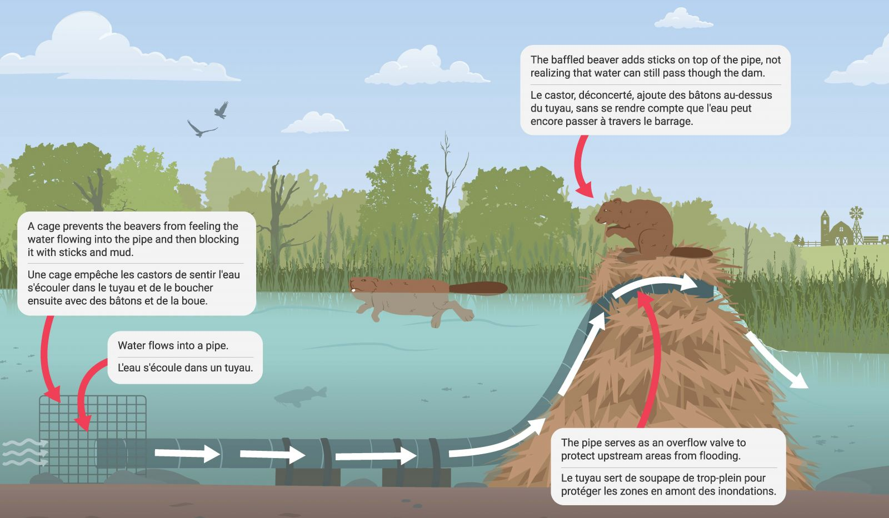
A Beaver Deceiver is a non-lethal device used to manage beaver-related water levels, preventing damage to infrastructure while allowing beavers to continue building their dams. It typically involves a culvert with a fence or pipe system that directs water flow and prevents beavers from damming the culvert. Repellents like Ro-pel can prevent a beaver from creating a dam but are not great once a beaver has already established a territory.
Cormorants
Cormorants, unlike the Anhingas whom they tend to be mistaken for, are usually spotted in bulk only in the winter. They are a native bird to North America and are therefore protected under the Migratory Treaty Act of the federal government. They are often regarded as pests due to their tendency to flock in large quantities and occupy docks along the lakes to dry off their wings in the sun. This then ultimately leads to a build up of feathers and feces on residences’ docks. The U.S. Fish and Wildlife Service now provides permits to shoot cormorants when they create an economic hardship. These permits are very restrictive! They only allow shooting a few birds to deter larger flocks from becoming habituated in stocked ponds and therefore are not a long-term solution for cormorant issues our community faces.
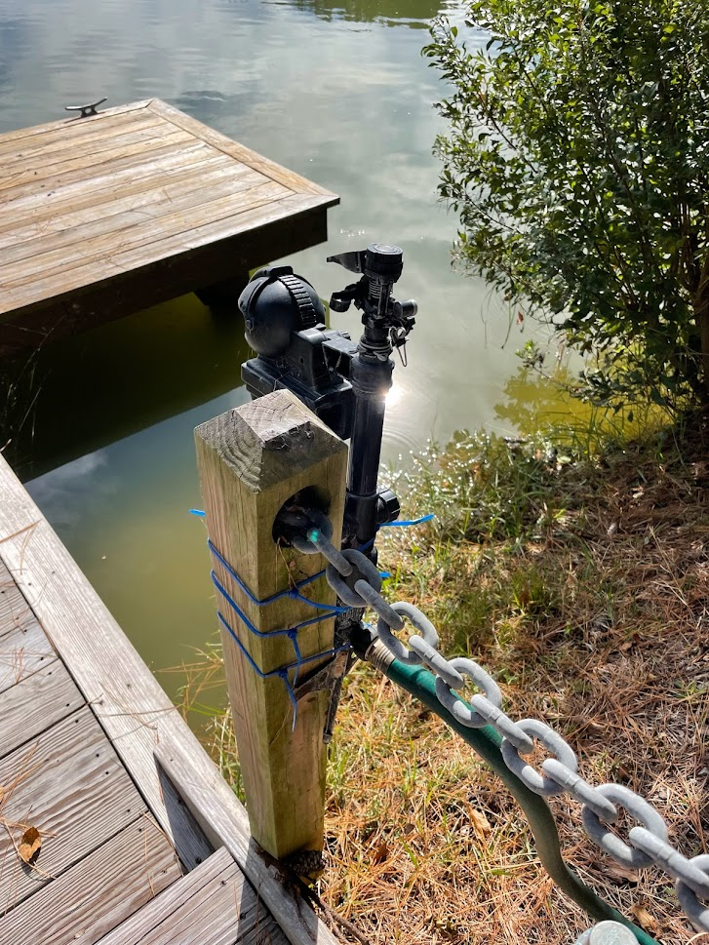
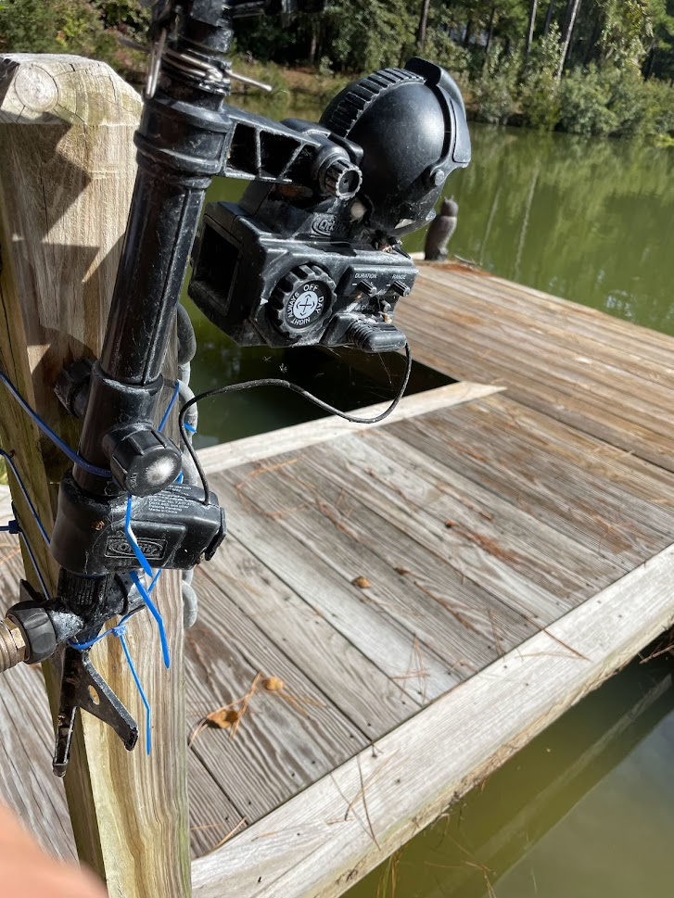
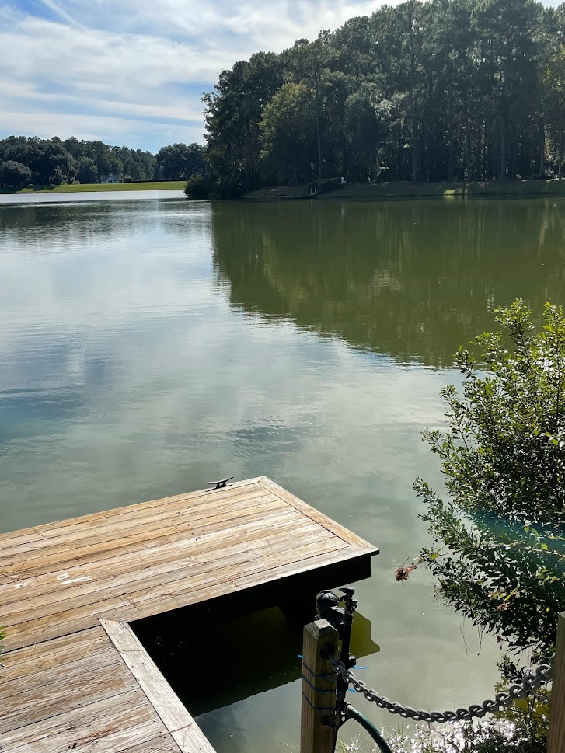
Problems with cormorants can most easily be avoided by installing a sprinkler system that is motion detected on your dock. The cormorants utilize the docks as a place to dry their non-water repellent wings, so if there is an area being misted with water, they will not stay there to bask in the sun. Installing the system at the base of the dock allows residents to switch it on and off during the winter months before accessing the dock and then completely off during the summer months when cormorants head back North. You can purchase these motion activated sprinkler systems from a wide variety of retailers including Amazon. See below photo for example.

Seagulls
Seagulls have a similar issue with Cormorants, though they are only typically nuisances in more oceanfront communities. Using noise machines or sprinkler systems like the ones above for cormorants can be effective for docks and marinas. For beachside residents, always be sure to keep food away from birds and do not encourage them to gather where people are. This can spread disease through feces and can be very annoying for your fellow beach goers!
DO NOT CHASE shore birds if you live on or near a beach. Allowing children or dogs to chase shorebirds (many of which are not seagulls but are species of terns or plovers who have just traveled thousands of miles) can actually cause them to die. Shorebirds have massive migration paths and can sometimes just stop on our shores to rest for only a few moments. Allowing pets or children to chase them down the beach can stress these already exhausted birds. Not to mention the majority of our shorebirds nest in VERY protective areas of our dunes. They have incredible camouflage and babies will often hold perfectly still when threatened. This causes people to often crush eggs and hatchling chicks under ATVs, cars, bikes, or even by running over them going through the dunes. Never walk through the dune system or drive/run above the high tide line in the spring and summer. Always keep pets below the tide line any time of year. Teach the next generation to be respectful of the birds who have traveled huge journeys to get here!
Deer
Managing the deer herd is critical to the long-term ecological health of our coast since a herd lacking predators strips the forest of new vegetation growth. New growth supports a complex ecosystem of moths and butterflies (in their caterpillar stage), pollinators, songbirds, and small mammals. A healthy herd density is approximately 1 deer per 10 acres in coastal GA (northern forests support much lower densities of deer), so deer populations need to be closely monitored. Effective management produces healthy deer herds that are characterized by large, mature bucks and balanced adult sex ratios. This approach typically involves the protection of young bucks and an adequate harvest of female deer to maintain a population that is appropriate for existing habitat conditions.
Given the high reproductive rates of deer in our region approximately 20-30% of the herd should be culled as needed to maintain a stable population. Culls take place with the cooperation of USDA, Georgia Department of Natural Resources and permits with GA law enforcement. Deer can be a big issue when it comes to homeowner landscaping as deer will browse on many different native plants in our area. For a complete list of what is and is not considered deer-tolerant plants, go to https://extension.uga.edu/publications/detail.html?number=C985. Zone planting (as discussed on page 24 is highly recommended for landscaping with deer in mind).
Unfortunately, due to huge pressure on our coast from local development and a lack of wide-scope planning, wildlife corridors for animals like deer to move through have all but been eradicated. This means many deer populations in suburban areas are becoming landlocked by development into smaller plots and overflowing into neighborhoods to survive. Utilizing conservation easements and community greenways along the edge of undeveloped space can be critical to moving deer out of your neighborhood effectively and giving them a path to move to other locations. Creating connection zones where animals and wildlife can migrate without risk of being hit by cars not only reduces wildlife issues but also costly and life-threatening crashes for people! Wildlife corridors are defined as linear areas of habitat that connect fragmented landscapes, allowing wildlife to move between different patches of habitat. These corridors are crucial for maintaining healthy populations, genetic diversity, and ecosystem function. They can be natural, formed by geographic features like streams, or more often found in communities that are adapting them into existing layouts, man-made, like underpasses or overpasses created for wildlife to cross roads. These can often be utilized by people too as a recreational access or amenity (trails, bike paths, etc.). For more information about wildlife corridors and if you can establish one in your community visit https://gaiacompany.io/wildlife-corridors-explanation-examples-benefits/
Coyotes

Coyotes are a species of small to medium sized canines that were originally found in the southwest and great plains regions of the North American continent. Approximately 400 years ago, upon the arrival of Spanish Europeans in those regions, the species began to expand its range due to several influencing factors. Europeans began applying intense pressure on wild predators viewing them as vermin or nuisances to livestock. These efforts were very successful in removing wolves, mountain lions, and bears from vast areas of the continent, including our own, but unintentionally spurred coyote populations upward. This was in part due to the absence of larger competing carnivores, but also because of the greater social flexibility of coyotes and their ability to increase litter sizes in response to pressure on the population.
Coyotes first began making their way into the Southeastern region of the United States in the late 1950’s and had become an occasional sight in our area by the 1990’s. Coyotes are occupying a role in the ecosystem here in Georgia that puts them in competition with bobcats and foxes that are native to the ecosystem. In some cases, they exist in the role of a larger predator on the landscape in the absence of species like the red wolf and the mountain lion that were extirpated from the area centuries ago due to the overhunting mentioned above. Coyotes do not fill these roles perfectly though, and can upset the ecosystem as well as come into conflict with humans. Because of this it is important to manage the coyotes in Coastal Ga to keep their numbers low and the animals that remain are fearful of people. Trail cameras are used to keep a rough idea of where and how many coyotes are in the region throughout the year, along with observing the deer, raccoon, and possum populations. It is recommended that communities install a trail or game camera in a non-obtrusive or common area to learn what animals are using the property.
Keeping dogs both large and small on leash in wooded areas minimizes the potential for any negative interactions with a coyote, as well as prevents issues with alligators, bobcats, people, and more. Just with the raccoon, you should make sure that cat food, dog food, birdseed, and household trash is not left where it might attract coyotes. Doing these things helps keep the coyotes from learning behaviors that cause them to come into closer contact with people.
It is rare and unlikely, but if you hear or see a coyote, you should wave your arms and make plenty of noise until they run away. While this might seem cruel or harassing, coyotes see humans as much larger and threatening so reinforcing that view by waving your arms, stomping your feet, and yelling loudly helps keep coyotes conditioned to stay as far away from people, pets, and houses as they can.

Bats
Awareness of the ecological value of bats is increasing because of the huge number of mosquitoes and other pest insects they consume. There are at least eight species of bats in the region. Some are colonial and others are solitary. The majority of bats that visit Coastal Ga are solitary tree bats and therefore utilize the ‘bat hostel’ style bat houses that are made for a single night's stay on a migratory path. The most common solitary species in our area are the Seminole bat, the evening bat, the southeastern myotis and the tri-colored (or pipistrelle) bat. The Mexican free-tailed bat, the little brown bat, and the big brown bat are cavity nesting colony bats that are found in our area too, so you can occasionally see youngsters of those species. If you should find a bat on the ground- DO NOT PICK IT UP WITH BARE HANDS. Contact your local wildlife rehabilitator for instructions and keep animals and children away from it until you can get more information from the rehabber, which you can find at animalhelpnow.org or on the Ga Department of Natural Resources Wildlife Rehabilitation List.
Commercial or homemade bat houses that are located on poles are an effective way to ensure that the bats come to your home, decreasing mosquito populations in your area naturally. Bat houses should be placed at least 12 ft off the ground to be successful and should be placed in open space in a direction that ensures morning sunlight heats up the box. Since we have harsh sunlight in this area, boxes are not needed to be stained or painted darker than a medium grey or walnut color. Occasionally houses located on trees may be raided by rat snakes. You can place the bat house on a metal pole or side of a building to help prevent this, but it is the circle of life for these creatures.
Wooden purple martin houses or bluebird houses on poles can also be utilized by bats at times. The favorite daytime roost for the beautiful mahogany-colored Seminole bat is among the dead fronds of a cabbage palmetto, so it is recommended to leave dead fronds on some of your palmettos to provide habitat for these bats.
At times bats select hollow columns on the exterior of homes as a roosting site or even possibly in your attic. If the accumulation of guano within the columns causes an offensive odor, or they are found inside, a reputable animal control company can remove the bats without killing them and plug up the entry points. This should be done in the early spring or late fall when there are not likely to be baby bats. The importance of a regular home inspection for entry points can not be overstated to prevent ALL wildlife conflicts from occurring!
Birds
Many homeowners thoroughly enjoy birds in their yards. But even birds can sometimes pose wildlife conflict issues. Having some type of glare reducing film on windows is encouraged to prevent birds from running into windows and injuring or killing themselves. Do not place feeders directly in line with windows to reduce the birds from leaving the feeders and running into windows. Placing stickers on windows can help them see the window panes better or utilizing streamers can be beneficial as well. These can be purchased from many online retailers including Amazon.
Preventing birds from nesting in your eaves or areas of your yard can be done with installed wire mesh or sealing up areas with spray foam. If you find a nest in a place that it should not be (ie- your garage, your wreath, etc.) if you can leave it, do so. It is illegal to remove active nests and we want to promote the bird population in Coastal Georgia, not hinder it! If it is in an area that you can not tolerate or is dangerous for the birds, preferably move the nest before the young hatch out of the eggs. If you find a nest that has already hatched and must be moved, do so slowly and incrementally so the mother bird can still find her babies safely. It is an old wives tale that if you touch a bird, they can smell the humans and will not return or neglect the chicks. They will still return and care for the young. If there is an abandoned nest that the mother has not returned to for several hours, contact the Naturalist so an appropriate rehabilitator can be located.
Woodpeckers are plentiful here at The Coastal Ga and can pose a unique challenge for some. There are three reasons a woodpecker may be pecking at your house, and is not something that should be ignored!
- The woodpecker is making small holes in your wooden structures. This can be an indication that you have termites! Woodpeckers peck small holes in the wood in search of insects and if you have a woodpecker bothering your home, he may be indicating to you a much larger problem that you should address immediately. Termites can quickly spread across an entire home and cause substantial damage to your property. Perform a proper termite inspection regularly and use quality pest control solution companies to ensure only termites are targeted and appropriate pesticides are being used. Repair all holes made in salvageable wood to prevent further issues.
- The woodpecker is making a large cavity in your home and it is approaching spring or is the beginning of spring. This is very concerning as it signals that you most likely have some form of wood rot already, and the woodpecker is starting to make a nest. Woodpeckers make their nests by pecking out large holes in softened wood for their young. If you notice a woodpecker is starting to make a larger hole, it is most likely that wood needs to be replaced and you must do so quickly before the woodpecker has fully formed the nesting zone. Woodpeckers are protected so moving a nest once it has laid eggs is illegal. Seal up any holes started by the woodpecker if the wood is not compromised to prevent it from continuing to expand the holes. Always perform regular home inspections for signs of wood rot and promptly replace compromised areas.
- The woodpecker is knocking on your home due to mating season and the sound produced by the wood. This can be a particularly challenging reason as it can sometimes not be solved as easily as the others. Woodpeckers use their knock on wood to attract mates. Males will bang their heads against particular types of wood to make resonating sounds to signal to females during mating season. This may include wooden structures around your home like eaves and siding. Using spray foam to dampen the sound produced by the woodpecker and thus making him less likely to return is the best way to prevent/solve this issue. Placing reflective streamers around the outside of the house to scare them away can also assist in preventing the return of the woodpecker but is not always guaranteed. Woodpeckers can be resilient and stubborn. Using motion activated noise makers can also be useful if the woodpecker is returning to the same place each time. These can be purchased on Amazon.
You can attract birds to your yard by offering them food, nesting habitat and water. The species of birds that come to your yard will depend on the habitat. Some birds need open areas and others need forests. Some species, such as chickadees and titmice, are generalists and are able to thrive in a wide variety of habitats.
Bird Feeders
Birdseed, suet, and sugar solutions are the most common foods used to attract birds. Birds with a large bill, such as towhees and cardinals generally prefer large seeds like black oil sunflower seed. Small-billed seedeaters, such as buntings and chipping sparrows, prefer millet and other small seeds. Goldfinches have a special fondness for thistle seed. Attract orchard orioles by putting out orange slices, shallow bowls of grape jelly or by having a hummingbird feeder that allows the oriole to perch while feeding.

Birds with slender bills typically eat insects, but they will also eat berries when available. High bush blueberries, brown turkey fig, native blackberries, and strawberries can quickly be depleted by visiting birds. Planting extra fruit plants than what you plan to harvest can help prevent issues with wildlife, particularly if you practice the barrier or zoning planting method. During winter, some of these species will eat suet cakes or homemade recipes of suet and peanut butter. Species attracted to suet cakes include woodpeckers, warblers, chickadees, nuthatches, wrens, and occasionally bluebirds.

To attract the ruby throated hummingbirds we have in this area, hang a couple of red hummingbird feeders filled with a solution of 4 parts water to 1 part sugar in mid-March. Do not add red dye to the water! The red feeder will be enough to attract the birds and the dye can cause permanent damage or death to the birds. Placing feeders on different sides of your house will increase the number of visits because hummingbirds are very territorial and will fight each other over the feeders. Feeders should be emptied and refilled once a week during warmer months to prevent mold. Even if you don’t see hummingbirds in the early summer you may attract them as they start their southern migration in July. Keep your feeders out as long as hummingbirds are present, which can sometimes go into mid-winter.

Birdhouses
Birdhouses attract bird species that typically nest in natural cavities that are often leftover nests created by woodpeckers. Bluebirds require open areas with large areas of short grass — they avoid wooded areas so place your box in a sunny spot that faces an open yard not too close to trees. Species that use a nesting box include chickadees, titmice, nuthatches and Carolina wrens. A box with a slightly larger opening might attract a great crested flycatcher. A funnel-shaped predator guard mounted on the box pole will reduce the risk posed by rat snakes and raccoons. Cleaning out boxes yearly, towards the middle of January is needed since Bluebirds will not reuse the same nest and will build them on top of one another causing blockages in the nesting box. Remove all nesting material and wipe out the box with a diluted bleach solution to prevent mold or bacterial issues. Coastal Georgia residents monitor bluebird boxes throughout the property and golf course and it is a great habitat restoration project!
Purple martins will also use birdhouses, but only if the martin house is in a wide-open area. Purple martins are most often found at the end of a dock or in a large, open field.
Dead trees or snags also provide habitat for birds that nest in cavities. Keeping dead trees that have fallen as well can act as ‘bug hotels’ that then encourage insectivores like bluebirds to visit more often. Consider lining the perimeter of your yard with dead trees, away from your house to prevent termite issues, but encourage natural habitat and food sources.

Water Features

Birds are attracted to water throughout the year. A water feature can be as simple as a dish under a faucet or as sophisticated as a recirculating, running stream of water cascading into a series of shallow pools. Drippers placed on a traditional birdbath will attract migrating birds. Birdbaths require regular maintenance because they quickly become overgrown with algae. Clean your birdbath with a weak bleach solution to kill algae and disease-causing bacteria.
If you are designing a water feature to be used by birds, make sure it has shallow areas (less than an inch deep) where small birds can stand in the water and bathe. You can accomplish this by placing several varied size stones on one side of a deeper bowl. This will also encourage butterflies and dragonflies, who typically avoid deep water they can drown easily in, to come and take a sip as well. A water feature with a gently sloping edge will provide varying depths for all sizes of birds. Water features with deep areas will attract small alligators, so be mindful.

Providing ‘Bird Habitat’ Provides Habitat for More Than Just Birds

Songbirds are abundant in Coastal Georgia throughout the year because of the diversity of habitats, abundance of insects, and numerous fruit-bearing plants. Caterpillars are an important food source during the breeding season so planting host plants is a great way to attract birds as well as increase pollinators in our area. Weedy areas with host plants for butterflies and moths create excellent summer and fall feeding areas that also support grasshoppers and other insects that overwinter in Coastal Ga.

If you plant the right species of shrubs and trees in your yard a wide variety of songbirds will be attracted year-round. The key is to provide berries in all seasons. In late summer fruits high in sugar are common. Some of the most popular native species are black cherry, devil’s walking stick and elderberry. In early fall the fruits of Virginia creeper, dogwood, beautyberry, blackgum and Jack-in-the-pulpit ripen and attract migrating warblers, thrushes and vireos. Sweetgum trees provide an excellent source of food for wood ducks and are recommended for homes near wood duck ponds, ephemeral wetlands and marshes. Some winter fruits, such as wax myrtle and sugarberry, have a long “shelf life” because they are high in wax. They are a critical food source during cold spells. Other fruits, such as the holly berries, remain on the plant for an extended period before birds such as cedar waxwings and wintering robins find them edible. Please avoid Nandina plants since they contain a toxin that builds up in Cedar Waxwings and can kill them when they are the only food source available during the winter in the area.

It is critical for songbirds to have the right habitat. Evergreen shrubs near a bird feeder or bird bath provide cover from Kestrel, Cooper’s hawk, and sharp-shinned hawk attacks. A healthy, wide natural perimeter of your property also attracts birds during the nesting season. Towhees, white-eyed vireos and barred owls nest within these forested strips between adjacent homes.

Painted buntings are a favorite species . Thickets for nesting, patches of native grasses in seed and herbaceous plants provide important habitat for painted buntings, especially when they have young. They love feeders filled with white millet seeds. Buntings become less prevalent in residential communities that are highly manicured.

Mosquitos

Mosquitoes are an unfortunate group of local biting fly species. They are most active during the warm months at dusk and dawn but can be present any day of the year if conditions are favorable. The females feed primarily on the blood of vertebrate animals and lay their eggs in standing water. Males do not bite and are actually considered pollinators. The larvae go through several different stages before transforming into adults. It takes a week or two after the eggs hatch for adults to emerge. Mosquitoes are a significant disease vector species and cause health problems throughout the world. In our region, encephalitis and West Nile virus are the primary diseases of concern.

Marsh mosquitoes are a very large species and are typically encountered along the edges of the marsh because they breed in fresh and saltwater puddles. They are a nuisance, but they don’t carry human diseases. They can, however, transmit heartworms to dogs.

The best way to control mosquito outbreaks is to kill the aquatic larvae. Check your property periodically to make sure there is no standing water in empty pots, storm gutters or vinyl covers. Mosquitoes are most likely to thrive when pockets of standing water are in the shade and have accumulated leaf litter. Ephemeral wetlands are NOT considered a mosquito rich environment due to the significant population of frogs it sustains.

An environmentally safe way to kill mosquito larvae in ditches and other pools of water is with a BTi tablet, or dunk, which contains a bacterium that attacks and kills the aquatic larvae while not harming vital water species. Mosquito magnets (carbon dioxide-producing units with mosquito traps) can reduce mosquito abundance in a small area such as a patio, but are not effective for an area as large as an entire home site. When working outside at dawn or dusk, use spray-on repellents or battery-powered units to discourage biting.

There is a spraying program with the Mosquito Abatement Department that does minimal environmental harm. If saltmarsh mosquitoes have blown in from other areas in the region a truck will spray pyrethrin or pyrethroid in areas where people congregate. A very low concentration is sprayed, typical at dusk or at night. Since the insecticide is absorbed through the wings of a flying insect, only very small insects flying at night are affected. Therefore, honey bees, butterflies, dragonflies and other diurnal insect species are not affected. This strategy impacts only areas within 150′ of the road. This insecticide breaks down within 3-4 hours and does not accumulate in the environment.

Sand Gnats or No-See-Ums

These tiny biting flies appear when air temperatures are approximately 65-75 ºF and there is little breeze. Therefore, they can be most problematic during the prettiest fall and spring days! They are common in moist sandy soils, on irrigated lawns or near the marsh. The best defense against these aggravating insects is to liberally apply an insect repellent with DEET to a hat and a lightweight long-sleeve shirt. Some people find a mix of Skin-So-Soft with an equal part of alcohol-based hand sanitizer works well to repel these biting flies.

Commercial companies now offer misting systems that claim to control no-see’ums in residential landscapes. The mist contains a pyrethroid insecticide that can also kill butterflies and honeybees as well as larval shrimp and crabs. These systems are not effective when there is a breeze. Prior to an outdoor social event on a lawn no-see’ums can be temporarily eradicated by a one-time application of crystals containing pyrethroids. These crystals should not be used near a wetland and should not be applied if rain is imminent.

Biting Flies

From Mother’s Day to Father’s Day every year we get a good collection of biting flies that include but are not limited to: Horseflies, deer flies, green headed flies, and yellow flies. They typically leave after mid-June. They are attracted to the color Navy Blue, Royal Blue, or Black so wearing light colors can be beneficial during this time. It is also recommended to wear clothing like a bug jacket that is a fine, breathable mesh that will not allow the flies to bite at the skin, similar to horse bug jackets.
You can rid yourself of these in your yard by hanging a blue or black ball covered in commercial glue called Tanglefoot, but monitor it so that no bees, dragonflies, and butterflies get stuck for long periods of time. Since flies prefer a moving target, placing a blue flower pot or cup coated in Tanglefoot on a moving object such as a lawn mower or golf cart and riding around attracts many deer flies to the cup and not you. This method was found to eliminate deer flies from an area over time if this was consistently done.
Purple martin houses swallows and warblers are a natural predator of biting flies. Placing purple martin houses around your property to attract them to your home can considerably help diminish the fly population during late May-Early June.

Fire Ants

The imported red fire ant (Solenopsis invicta), is an invasive species that was brought to the United States during the 1930s. The species has now infested much of the southern United States. Fire ants can inflict quite a painful bite and sting. In certain cases, fire ant stings can be severe, resulting in anaphylactic shock and, in extreme cases, death. Non-life-threatening stings are treated with antihistamines and topical hydrocortisone. Fire ants build nests and live in colonies that usually consist of above-ground mounds and elaborate underground chambers. They may be found in rotting logs, under building foundations or around trees and stumps.
If the mound is disturbed, fire ants will quickly rush out to attack aggressively. Colonies are more commonly found in open, sunny areas such as lawns, fields and pastures. Fire ants are not usually found in forested, shady areas. They are omnivores and feed on a variety of foods including other arthropods, worms, seeds, nectar and even human food. Fire ants can have a major economic and ecological impact on areas they infest by injuring livestock, damaging crops and harming native species.
The eradication of fire ants is impossible. However, they can be controlled on a local scale by using a baited insecticide. Treating a yard by broadcasting the insecticide is a less desirable means of killing fire ants, as it will also kill other beneficial native insect species. It is important to follow package instructions when using commercial baits. It will take several days for even the best product to work. Care must be taken not to apply the bait near the edge of the marsh because the active ingredients kill a variety of arthropods, including crustaceans.

Wasps, Yellow Jackets, and Hornets

Yellow jackets make their nest underground, typically at the base of a tree while hornets, like the Bald Faced Hornet, are more likely to hang in a tree or on the eaves of a structure. Wasps like the Paper Wasp or smaller Guinea Wasp, will typically construct umbrella-shaped nests inside of structures. The mud-dauber is a harmless insect that makes a mud coated nest and can typically be mistaken for a wasp.
Even though all three types of flying insects can be beneficial to your space by eating other pesky pests, they are still aggressive, stinging insects. They will attack you if you disturb their nests. In the late summer, they will even sting if you simply get too close. Do your best not to disturb a nest. If you disturb a nest by accident, stay far away from it until the insects have settled down. This is particularly difficult to do with yellowjacket nests since they are underground and difficult to detect. Try to keep an eye on where they are burrowing.

If you think you’re going to be around a nest, wear a long-sleeved shirt and pants to cover as much of your skin as possible. If a wasp lands on you, try to stay calm until it flies away. It’s also important to keep an eye on your sugary drinks! Wasps love soda, beer, and other sugary beverages. Remind your picnic guests to watch out for the stinging insects!
Although wasps can rid your space of other pests, they can be a nuisance and they can be dangerous. If your yard is a popular hangout spot for wasps, get specific treatment that will not harm surrounding insects with pesticides that linger in the soil, such as EcoSmart sprays or homemade vinegar based sprays. Utilize wet vacuums for safe removal of the entire yellow jacket nest, but do so after you are sure that all the insects are already dead. Removal should be done in the winter if possible, when the insects are in diapause and are less likely to sting.
Ticks
Ticks are external parasites that feed on the blood of vertebrate animals such as birds, mammals, reptiles and amphibians. When ticks sense the chemicals released by the host (butyric acid) they drop from vegetation and attach themselves to the host with their mouthparts, feed on the host’s blood and drop off. They can transmit dangerous diseases like Lyme disease, Rocky Mountain Spotted Fever, Ehrlichiosis and Tick Paralysis. Lyme’s disease is not as prevalent in the South as it is up North but still can be contracted here. The best way to prevent tick bites is to wear long pants when in the woods, wear DEET insect repellent around the ankles, and to wash all clothing as soon as you return to the house. Be sure to conduct a body check for unwelcome hitchhikers! If you regularly spend time outside, pay attention to any areas that itch like a mosquito bite.
Chiggers
People vary dramatically in the way they respond to the bite of a chigger (also called a red bug). Some people exhibit no reaction while others have strong allergic reactions in the form of a highly itchy bump that persists for several days. Chiggers are the larvae of the harvest mite and are so small that they are usually not visible to the naked eye. It is a misconception that they bury under your skin, they do not! The organism attaches to the skin and injects digestive enzymes that dissolve skin cells that the chigger then feeds on. The skin reacts to a microscopic feeding tube left in the skin by the departed larva.
Chiggers are more active during the warm months (April to October). The best way to prevent bites is to keep the chiggers from reaching your skin in the first place. Wearing rubber boots with long pants tucked into the boots and using DEET repellant spray can help. Wash all clothes and place them in a hot drier before wearing them again. Take a hot shower when you get home, scrubbing areas where chiggers tend to attach. For some people, the severity of chigger bites lessens with time.
Alligators
The American alligator is one of the most spectacular animals in the southeastern United States. Once a federally endangered species, alligators have recovered and are an integral part of the Coastal Ga identity. They are present in essentially all freshwater bodies in the Southeast as well as saltwater marshes. The basic body of the alligator has not changed since the time of the dinosaurs. Males can grow to 10-12′ (300-450 lb) and females grow to 7-9′ (100-200 lb). In the wild, alligators may live more than 70 years and some individuals in captivity have been documented as being over 100 years old! Alligators move among ponds and into the surrounding marshes, creeks and rivers. The range of adult males can exceed 2,000 acres and individuals occasionally travel many miles in search of mates and food. Females tend to hold on to territory while a male will have several females that he visits during the mating season.

During their courtship and mating season (April and May), males often bellow to attract females and warn off competing males. In June and July females lay 20-60 eggs in a nest constructed from leaf litter, vegetation and mud. Hatchlings are typically under 8-10 inches long and during the first 1-3 years of their life stay with mom. Juvenile alligators eat small fish, amphibians, insects, snails and crustaceans. Adult alligators feed on fish, turtles, snakes, birds, mammals and other alligators. Alligators are often seen in the marsh because blue crabs and mullet are among their favorite foods. Alligators are ectothermic (cold-blooded) and their feeding activity is dependent on body temperature. They are therefore typically inactive during the winter months in a state known as Brumation and are rarely seen except on warm winter days when they may come out to bask in the sun. Alligators seek refuge in dens, often constructed under pond banks.
When stressing that wildlife should NEVER be fed, it is excessively important to understand this is not just for the safety of the animals! With the case of the alligator, direct feeding or indirect feeding such as tossing out scraps or fish can lead to human death. Alligators have incredible learned behavior and it only takes one instance of feeding for them to learn that humans may give them food. Alligators are very defensive creatures, who unlike their saltwater crocodile cousins do not see humans as a food source as we are too large. Alligators are not aggressive towards humans unless provoked or if they have been previously fed. A fed gator is a dead gator!
Alligators are very lazy creatures and will take the easiest option when it comes to diet. This is why most alligators are actually cannibalistic and will eat younger gators that will be easier targets rather than trying to go after a large mammal. This is also why we do not remove alligators based on size alone, the larger alligators are controlling the population of the smaller gators. As an apex predator, larger alligators are also essential to the balance of prey animals like deer and raccoons here in Coastal Ga. Reckless reduction of the population can have extensive consequences that can cripple an ecosystem, costing a community millions of dollars to recondition.
Alligators can very rarely be successfully relocated as they have a strong homing instinct and will swim and walk miles to return to their territory.Even if alligators are removed, more alligators are likely to take its place as it is still a good habitat with the necessary resources needed to support them. Constantly removing all alligators in an area creates an endless cycle of removing and killing alligators that is not sustainable for the ecosystem.. Alligators provide many ecosystem services including population control, habitat creation and nutrient cycling. Scientists have even discovered that wading birds are more likely to roost and nest in areas that have alligators. If they are not causing an issue, then they should be left alone as they benefit our ecosystems in many ways.
Instead, communities should aim to coexist with our alligator neighbors by having signage that warns of the presence of alligators and providing education for new and existing residents. Some general rules that will allow for safe coexistence of alligators and humans are, assume there is an alligator in all bodies of water. Never walk your dog by the edge of the water as they are a four legged animal and alligators see them as a prey item. One should avoid crouching by the edge of the water as an alligator can confuse a crouching person for a potential prey item. Children should always have adult supervision when by the edge of the water, this includes fishing. Swimming should only be done in designated areas and swimming should NEVER be allowed in retention ponds. When recreating by the edge of the water do not reach into the water to try and retrieve your golf ball or any other object. Kayaking can be done safely with alligators where it is allowed as alligators see the large kayaks and will move out of the way out of fear, but one should keep hands and feet inside of the vessel. Make sure to give alligators plenty of space and NEVER feed an alligator. A healthy respect of alligators, and all large predators in general, is needed, but no one should be overly fearful of alligators.
Alligator management techniques for communities can range from surveys and tagging to specific alligator intervention. Spotlight surveys are conducted at night to monitor population size, density, and age structure, generally identifying 3-4 classes (hatchling, juvenile, sub-adult, adult). Alligator tagging is a crucial management tool. Research tags are placed on captured alligators’ tails to help track their movements and also encourage them to keep a safe distance from people, as the brief capture experience reinforces natural wariness of humans. Research tags, including GPS and visual markers, help monitor movements and reduce human-alligator conflicts.

Native Plants
A native plant community, left undisturbed and incorporated into a landscape, is low-maintenance and self-sufficient. Today, there is a growing interest in preserving native landscapes as “green space” in residential communities, giving them a park-like ambiance and providing space for birds and other wildlife. A casual stroll through a woodland setting teeming with ever-changing flora and fauna is a relaxing and peaceful diversion from our daily lives.
Native plant areas provide “watchable” wildlife habitats. Native butterflies, insects, birds, mammals, reptiles and other animals evolve with the native flora and are sustained by it year round, providing diverse food, shelter and support for native food webs. They also create a sense of place, fostering appreciation of our natural heritage and the diverse beauty of unique regional landscapes.
Weather extremes, either temperature or drought, have shown us one of the best and most practical reasons for using native plants — their adaptations to local climate. Plants grow where they do because they have finely adjusted to the local environment. Environmental features such as moisture, soil pH and sunlight level of a smaller, more focused area, are called the microclimate. Subtle changes in microclimate influence where native plants grow.
These plants have also extremely well adapted root structures for our local soils. While many communities have been built up on solid layers of clay or compacted materials, utilizing native plants with an initial soil amendment can help revitalize the soil. Many native species help trade nutrients in the soil, and operate at much further depths than grass or non-native ornamental plants. This means that natives can help repair the soil composition around you. Using compost and reducing insecticide and herbicide use as much as possible can also help along the soil. The more hardy the soil is, the less likely topsoil erosion will occur, which can lead to nutrient depletion across a yard. There is also the consideration of bank management and for homes on hills or higher ground. The erosion that can occur at edge habitats can be extreme with increasing weather events like hurricanes and flash floods. This makes maintaining the health of your soil even more important to the health of your foundation and home!
Understanding where to plant these plants is equally important. Please do your research! Live oaks, for example, should never be placed up close to a home’s foundation. These trees are extremely sturdy, but that is because their root system can extend wider than the tree is tall! These roots are also powerful and can rip up concrete in their growth. Do not plant trees like these near concrete borders, sidewalks, or homes. Smaller trees like Eastern Redbuds or dogwoods are more suitable. Leave the live oaks to larger plots and alleys.
Good soil preparation is essential for satisfactory plant growth. Dig a large hole at least two times wider than the root ball of the plant and as deep as the root ball. Remove any rocks, roots or other debris from the excavated soil and work it up thoroughly. Set the top of the root ball level with the soil surface or slightly above the surface if the soil is prone to settling. Then backfill with the same soil removed from the hole and water thoroughly to remove air pockets. Mulch with pine straw, pine bark, hardwood mulch or other organic material.
Below is a sample of some of the native plants you can use in your yard. This is by no means an exhaustive list, but a good place to start!

Shrubs/Small Trees

American Beautyberry / Callicarpa americana
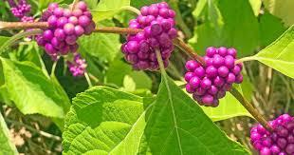
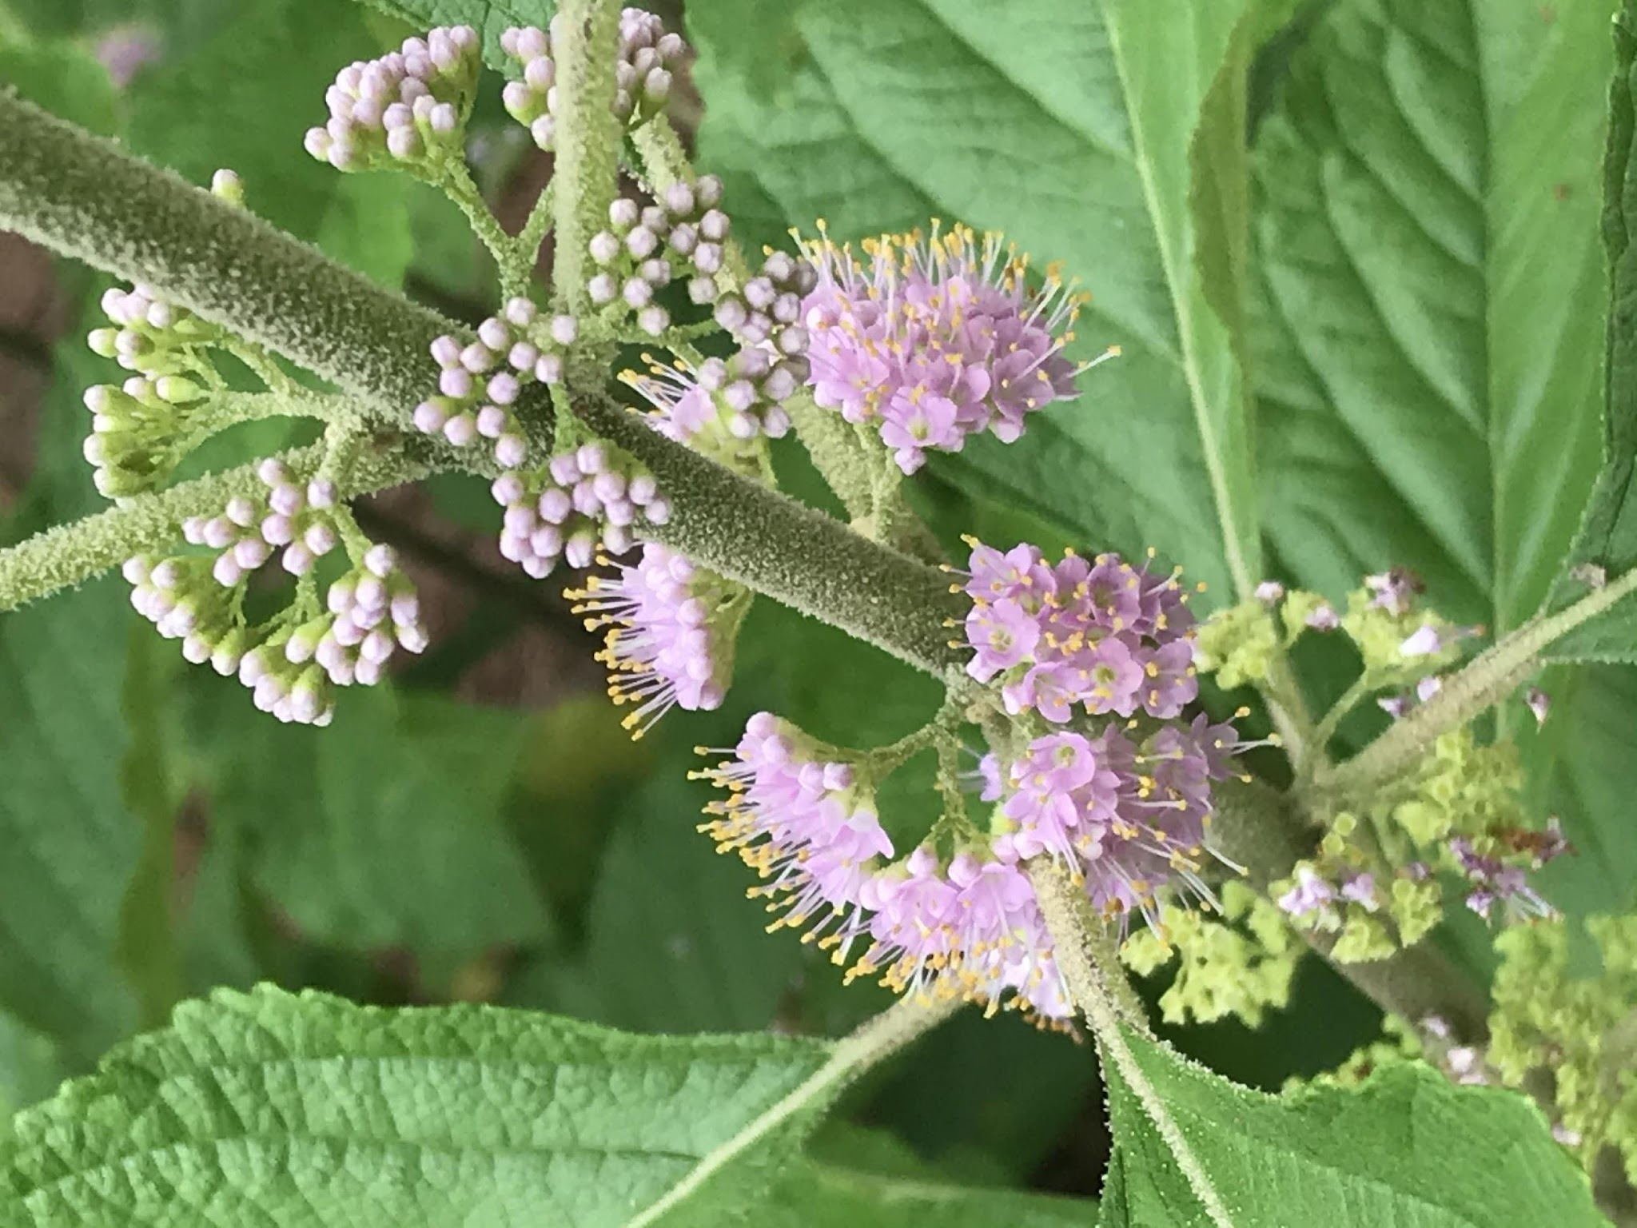
Characteristics: American Beautyberry is a deciduous shrub with textured leaves and medium to fast growth rate. It has a spreading, loosely branched, upright growth habit. The purple flowers that emerge from June to August are very fine, but the intense color of the purple fruit clustered around the stems in fall makes a dramatic display attractive to humans and native birds. Mature plants grow 4-6’ in height with 4’-5’’ width. Beautyberry can be planted in a variety of sites: wet to dry, sun to shade.
Landscape Uses: American Beautyberry is a great accent in the shrub border. It will grow in most soils and prefers full sun for best fruit production. It is adaptable to a wide variety of sites. The textured leaves and showy fruit make this species desirable for naturalistic settings or mixed shrub borders. Best planted in groups of three, five, or seven for a dramatic statement.

Blueberries / Vaccinium
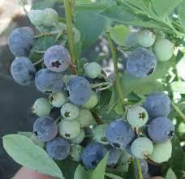
Characteristics: “Rabbiteye” blueberries are native to Georgia and are harvested here from late May through mid-July. Under good management, blueberry bushes will produce some fruit the second or third years after planting. By the 6th year, they can yield as much as two gallons each! These bushes are sold in sets, since successful fruiting is promoted with the cross pollination of the two bush varieties.
Choose: option #1: Early season ‘Titan’ variety paired with “Vernon’ or option #2: early season ‘Vernon’ paired with ‘Alapaha’
Plant in a sunny location five to six feet apart, mulch with pine bark or pine straw; adequate water is essential for plant growth and fruit production. Plants mature to 6-8’.

Buttonbush / Cephalanthus occidentalis
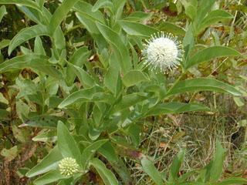

Characteristics: Buttonbush is a spreading, multi-branched shrub or sometimes small tree covered in balls of white flowers resembling pincushions that appear in mid- late summer followed by button-like balls of red fruit. Buttonbush is a handsome ornamental suited to wet soils and is also a highly desirable plant for honeybees. Ducks and other water birds and shorebirds consume the seeds. Can reach heights of up to 10’.

Landscape Uses: Useful in areas that are wet and perfect for creating wildlife habitats for birds, butterflies and specifically honey bees – drawing the attention of both pollinators and people.

Dogwood / Cornus florida
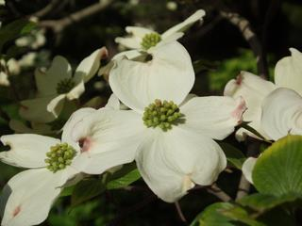
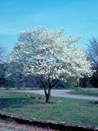
Characteristics: The flowering Dogwood is of the most widely planted deciduous ornamental trees in Georgia. It is native to the eastern United States and can be found growing throughout Georgia, as an “understory tree” in the dappled sunlight of pines and hardwood trees growing around it. The showy parts of the white dogwood flower are actually bracts (like those of a poinsettia), which are modified leaves that turn color. Dogwoods are not difficult to grow when they are planted properly in fertile moist soils, and are not left to dry out with too much sun exposure. Bright red berries attractive to native birds follow the flowers; fall leaf color is red. The mature height is 20’-40’.

Eastern Redbud / Cercis canadensis
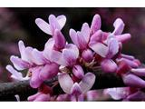
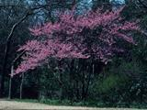
Characteristics: Stunning tiny pink flower clusters cover the entire tree before leaves emerge in March -April. Redbuds mature into a 15-30’ tree with several picturesque branches that create a wide umbrella-like crown. Flowers are followed by small flat seed pods 2-4” long that can remain on the tree through winter. Smooth, heart-shaped, deciduous foliage turns golden in the fall. Trees from the southern part of the species’ range have smaller, glossier leaves.
Landscape uses: Easily grown in well-drained moderately fertile soils in partial shade, especially in naturalized woodland settings here in the South. Plant small younger trees in groups where they can be left undisturbed, with ample space to grow. Redbuds make beautiful understory trees that attract native butterflies.

Elderberry / Sambucus canadensis
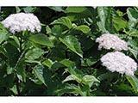
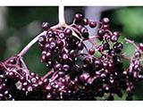
Characteristics: Black elderberry become a loose, graceful, vase-shaped collection of deciduous shrubs with both woody and herbaceous branches that can reach heights of 5-12’. Tiny lemon-scented showy white flowers appear in large flat-topped clusters in May-June, giving way to clusters of black elderberry fruits in late summer. Fruits are used to make jams, jellies, pie fillings, and elderberry wine.
Landscape Use: This deciduous shrub grows in full sun to partial shade and can create thickets at the edges of woodlands that are attractive to wildlife. Elderberry plants tolerate a wide range of soil types and can be grouped or massed in natural settings. Attractive to wildlife and many pollinators, it is a good sprawling hedge. Elderberry can combine beautifully with the Fetterbush listed below to create a tiered effect at the edge of a bright woodland.

Fringetree/ Chionanthus virginicus
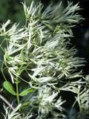
Characteristics: This 15-30’ deciduous tree is filled with drooping clusters of fragrant, white blossoms in the spring -–the habit described by its name! The numerous delicate fragrant, white flowers are composed of 4-6 strap-shaped petals 1 inch long by 1/16 inch wide. They hang in showy, branched clusters 4-6” long. Flowers open before or with the first leaves. Dark-blue, grape-like clusters of fruits follow the flowers produced from female blossoms and are enjoyed by the birds. Other features are dark-green, glossy foliage and a pale-gray trunk with bands of white.
Landscape uses: Chionanthus grows easily in moist fertile soils, in full to partial sun, and seldom need pruning. They make beautiful specimen trees, especially along woodland borders.

Florida Leucothoe / Agarista populifolia
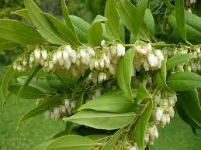
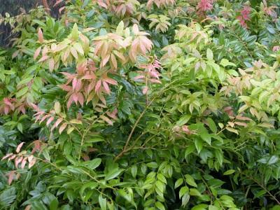
Characteristics: A Southeastern native that is perfect for foundation plantings; it is multi-stemmed, with arching branches that give a soft, informal appearance. Racemes of fragrant creamy-white flowers appear in May and June beneath shiny narrow leaves. New growth foliage is tinged with red becoming deep green as the leaves mature. Mature height is between 8’-12' with a spread of 5’-6'.
Landscape uses: The plant tends to sucker and is good for stabilization along moist shady banks. It is useful as an understory planting in woodlands, along stream banks and for screening in moist shade. Disease and pest-free; dependable and easy if sited well. Prefers partial shade but tolerates sun with adequate moisture.

Fetterbush / Lyonia lucida
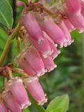
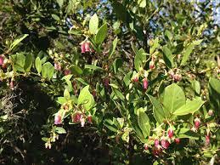

Characteristics: Fetterbush is a high suckering, open, arching evergreen with an urn-shaped growing habit. The pinkish-white flowers bloom at branch tips from March through May. The attractive foliage is glossy-green and leathery. Shrubs grow between 3’-6’ in height, with a spread of 6’. Plant these shrubs in partial shade and in moist soil, but they are intolerant of standing water.

Landscape uses: Fetterbush thrives in wetter areas, reflecting where it grows in the wild acidic soils of Richmond Hill. It is an elegant choice where a naturalized woodland effect is desired.

Red Buckeye / Aesculus pavia
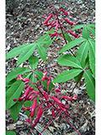
Characteristics: Red Buckeye is a round topped, deciduous flowering shrub or small tree. The lustrous, dark green, palmate leaves have five leaflets. Scarlet flowers are borne in panicles 4”-8 “ long and 2”-3” inches wide in March and April. Fruit are capsules approximately 2 “ long, bearing one or two lustrous brown seeds. The plant grows 12’ - 15 ‘ tall and 8’ - 10 ‘ wide.
Landscape Uses: Red Buckeye is an attractive spring flowering shrub useful in woodland settings where it gets filtered shade and moist conditions. It flowers well in dense shade. It loses its leaves early, often by late September. Scarlet, tubular flowers with protruding stamens are pollinated by migrating ruby-throated hummingbirds. Plant in swampy, marshy areas to fertile, moist, well-drained lower forest slopes.

Summersweet / Clethra Alnifolia
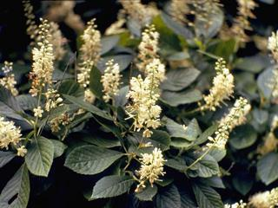
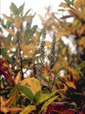
Characteristics: Summersweet plant, also known as pepper bush, is an ornamental shrub with spikes of spicy-smelling white flowers attractive to many pollinators. Blooming often takes place in summer around July or August. Its attractive dark green foliage takes on a yellow to orange color in autumn, making this plant even more spectacular. The shrub grows 5 - 7’ high and spreads about 6- 8’ across. It also prefers moist to wet soil that is slightly acidic. Summersweet plant can be grown in sun or partial shade.
Landscape uses: Summersweet is commonly used in the landscape as either specimen or group plantings in borders or near foundations. It’s also used as a naturalizing shrub.

Climbing Perennial Vines

Climbing Aster / Aster carolinianus
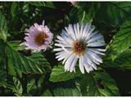
Characteristics: The Climbing Aster is a sparsely branched plant with a woody stem and branches that climb to 6’-12’ or more in height. Flowers that are lavender to pink are large and numerous form at the ends of its many small branches. The plant thrives in sunny areas with various soils, and blooms September – October. Landscape uses: Perfect for trellis or fence trailing, and nice to pair with confederate jasmine since it’s bloom time is fall.

Coral Honeysuckle / Lonicera semperviens
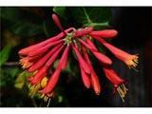
Characteristics: This high-climbing, twining vine grows 3’-20 ‘ long with smooth, glossy, paired, semi-evergreen leaves and 2-4 flowered clusters of red, tubular blooms with yellow insides followed by bright-red berries for the birds. The papery, exfoliating bark is orange-brown in color. The vine is frequently visited by hummingbirds, and is not too aggressive. The species name refers to its evergreen habit in the South. It blooms March – June and is adaptable to sun and partial shade.
Landscape Uses: Perfect for trellis, columns, fence or pergola adornments where you can watch hummingbirds and other pollinator visits.

Crossvine / Bignonia capreolata
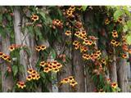
Characteristics: Crossvine is a climbing woody vine reaching 36-50’ in length that blooms March – May with showy yellow, orange to red trumpet-shaped flowers, 2 inches long clustered in groups of two to five. Tendrils hold fast clinging to stone, brick and fences without support. Persistent glossy semi-evergreen leaves change to purple in winter. Plant in sun or partial shade in moderately moist soil.
Landscape Uses: Crossvine is a vigorous fast-growing cover for fences, arbors, walls, large trellises and other structures.

Purple Passion Flower / Passiflora incarnata
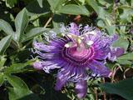
Characteristics: The purple passion flower is an herbaceous vine, up to 25’ that climbs with axillary tendrils or sprawls along the ground. Intricate 3” lavender flowers are short-stalked from leaf axils. The petals and sepals subtend a fringe of wavy or crimped, hair-like segments. The pistil and stamens are also showy. Three-lobed, deciduous leaves are dark-green above and whitish below. The fruit is a large, orange-yellow berry with edible pulp. Like some other passion vines, this “maypop” spreads by root suckers. It blooms in April through September in sun and partial shade in moist to fairly dry conditions.
Landscape Uses: Trellis, fences, pergolas.
Perennial Plants
Beach Goldenrod/ Solidago sempervirens
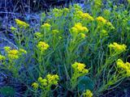

Characteristics: This tall fall-blooming perennial has elegant arching branches and deep-yellow flowers with leaves are somewhat succulent. Growing 3-5’ high, it thrives in bright sun, is non-invasive unlike other golden rods, and is highly attractive to most fall visiting pollinators.
Landscape Uses: Plant with other fall blooming perennials such as Cut-leaf Coneflower, Joe Pye Weed, Swamp Milkweed, Spotted Bee Balm, Black-Eyed Susan, and ‘Northwind’ switchgrass for a kinetic meadow-like effect filled with pollinators.

White Baptisia / Baptisia alba
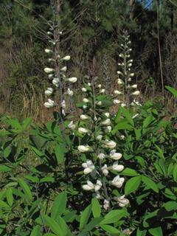
Characteristics: Commonly called white false indigo, this striking upright perennial typically grows 2-3’ in height and 2’ in width with white pea-like flowers and blue-green leaves. Expanding over time, the plant forms a small colony with deep root systems. Plants tolerate full to partial shade and droughty conditions in average soil.
Landscape Uses: Plants naturalize well, blooming April – May and are attractive to butterflies. Stems with seed pods are valued additions to dried flower arrangements

Blanket Flower / Gaillardia
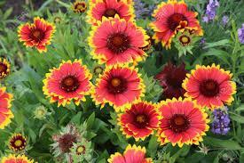
Characteristics: Gaillardia is an easy to grow perennial with richly colored, daisy-like flowers in yellows, deep oranges, and reds that bloom in early summer through fall. Gaillardia forms a slowly spreading mound and will "blanket" an area – hence the common name. Grows 12-18” in height with a width of 12-24”.
Landscape uses: Plant in full sun in well-drained soil for a colorful display in the front of the garden.

Bergamot / Monarda fistulosa
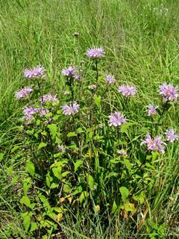

Characteristics: Wild bergamot, known by many other common names such as bee balm, is a popular and showy perennial. Clusters of lavender, pink or white flowers, looking like ragged pompoms, bloom atop 2’-5 ‘open-branched stems. Bergamot blooms May – September, and thrives in sun to partial shade. This showy perennial has aromatic leaves used to make mint tea. Oil from the leaves was formerly used to treat respiratory ailments.

Black-eyed Susan / Rudbeckia hirta
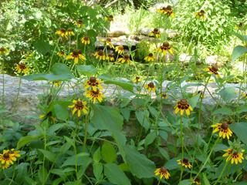
Characteristics: Bright-yellow, 2”-3“ wide, daisy-like flowers with dark cone centers occur singly atop 1’-2 ‘ stems. The stems and scattered oval leaves are coarse in texture. This native prairie biennial forms a rosette of leaves the first year, followed by flowers the second year. Blooms June through October in sunny dry or moist conditions. Birds (especially finches) enjoy the ripe seeds.
Blue Flag Iris / Iris virginica
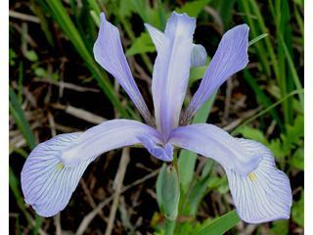
Characteristics: A southern wetland species occurring from Virginia to Florida, Iris virginica is 2 ‘ tall with bright green leaves that often lie on the ground or water. Southern Blue Flag is a member of the Iris family that consists of plants growing from rhizomes, bulbs, or corms, with narrow basal leaves and showy clusters at the tips of long stalks. It flowers in May and June in moist conditions.
Landscape uses: Plant along edges of ponds
Blue Sage / Salvia azurea
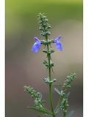
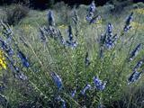
Characteristics: Blue sage is a clump-forming perennial that typically grows to 3-5' tall and 2-4’ wide. Whorls of azure blue flowers bloom in spikes from mid-summer to fall atop stiff stems clad with linear grayish-green leaves. This plant thrives best in partial shade and requires moderate watering conditions.

Dense Blazing Star / Liatris spicata

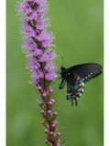
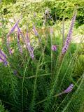
Characteristics: Dense blazing star is an erect, slender perennial reaching a height of 3-4 ft. The linear, grass-like leaves are clumped toward the base of the plant, but extend up the stem to the showy flower cluster. A tall spike of rayless, rose-purple (sometimes white), closely set flower heads. The purple, tufted flower heads are arranged in a long, dense spike blooming from the top down, July through September. Blazing Star plants prefer full sun and soil that is evenly moist. This plant is highly attractive to pollinators such as bumblebees, butterflies, and hummingbirds.

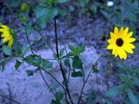
Dune Sunflower / Helianthus debilis

Characteristics: The dune sunflower has flower heads composed of bright yellow rays with red disks that grow on hairy, red/brown stems. It has a “decumbent” habit with stems that will sometimes grow sideways on the ground and have an ascending tip covered in flowers. Leaves may be entire or shallowly lobed. Thriving in the sun and in sandy soils, it can bloom from spring through to fall.

Dwarf Crested Iris / Iris cristata
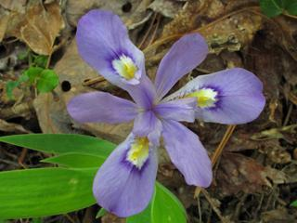
Characteristics: This is a small iris, with clusters of narrow pointed leaves ranging in height from only 4”-16 “. The sepals of its blue-violet flowers are distinctly marked with a central yellow or white, purple striped band. Crested ridges called beards occur along the band. It thrives in shade to partial shade, and blooms March through May.
Landscape Uses: It should be planted in areas of damper soil and would be excellent along lake banks.

Georgia Savory/ Clinopodium georgiana
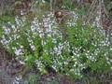
Characteristics: Georgia Savory is a small, semi-evergreen shrub with aromatic leaves. Flowers are tubular, pink to lavender in color, and are borne from July through frost. It is a striking plant in bloom. Habit is loose, open and erect, and a magnet for pollinators. Mature size is up to 2.5 ‘ high with a spread of 2’.
Landscape Uses: Great small native shrub plant has lovely blooms that remind you of rosemary. It adapts in sun to filtered bright shade and tolerates moist to dry soil. It is semi-evergreen and native to the Southeastern US. Georgia savory reseeds freely, and it typically remains evergreen.

Green and Gold /Chrysogonum virginianum var. brevistolon
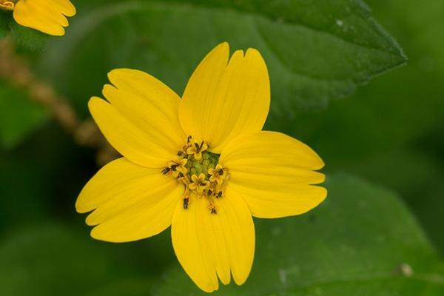
Characteristics:
Green and Gold is a native, rhizomatous, low-growing perennial that makes a great groundcover choice for an area that is part sun/part shade. It is low-maintenance and looks great with columbine and Virginia bluebells. The foliage is semi-deciduous, and the yellow, daisy-like flowers that are about 1.5" in diameter. The plant forms basal rosettes and spreads primarily via stolons (less so by rhizomes) to create dense mats of interconnected clumps. Green and Gold prefers moist acidic soil with organic matter added. Plants bloom March – June, will stop during the hot summer months, and may reappear as fall temperatures drop.

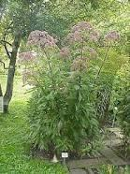
Joe Pye Weed / Eupatorium purpureum

Characteristics: Joe Pye Weed is a tall native perennial that occurs in low moist soils, wooded slopes, wet meadows, thickets and stream margins. It is an erect, clump-forming perennial that typically grows 4’-7’ tall and features coarsely serrated, dark green leaves up to 12” long in whorls of 3 to 4 on sturdy green stems with purplish leaf nodes. Tiny vanilla-scented, pink/purple flowers in large, domed, compound clusters bloom in mid-summer to early fall. Each flower cluster typically has 5-7 florets. Flowers are very attractive to butterflies. Flowers give way to attractive seed heads that persist well into winter.

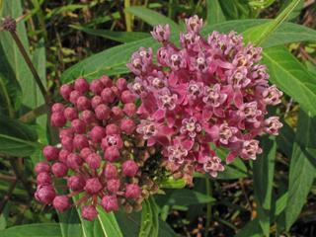
Milkweed /Asclepias incarnata
Characteristics: The large bright terminal blossoms of this showy 2’-4’ high perennial are made up of small, rose-purple flowers that grow on a tall, branching stem, bearing numerous narrow lance-shaped leaves. Elongated, tan-brown seed pods persist into winter. Blooms June through October in moist soils, in sun to partial shade. Attractive to all butterflies, but it is an essential food source for monarchs.
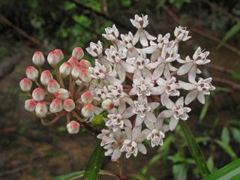
Milkweed / Asclepias perennis
Characteristics: This species can be easily identified before the flowers open because the tips of the corollas are pink creating a large pink spot at the apex of an unopened flower. Leaves are relatively short and narrow, and are attached to a stem that is purple-green in color. Grows to a height of 3-6 in areas of sun or partial shade with soils that are continuously wet. Blooms May through September. This plant is highly attractive to butterflies and most pollinators.

Pink Beardtongue /Penstemon australis
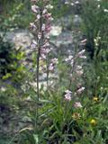
Characteristics: This perennial member of the snapdragon family has deep-rose tubular flowers in pairs at the top of hairy flower stalks that grow 1-2 ft. tall and bear pairs of lance-shaped leaves. Delicate flowers bloom April through July, and can thrive in dry soils in partial shade. Penstemon australis is highly attractive to native bees.

Spotted Bee Balm / Monarda Punctata
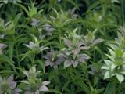
Characteristics: An aromatic, erect perennial ranging from only 6“ to almost 3’ tall. Rosettes of yellowish purple-spotted tubular flowers occur in whorls, forming a dense, elongated spike at the end of the stem or from leaf axils. Each whorl is subtended by large conspicuous white to purple-tinged, leaf-like bracts. Spotted Bee Balm blooms April through August in sunny dry conditions. Bee Balm is recognized by pollination ecologists as attractive to large numbers of native bees.

Stokes Aster / Stokesia
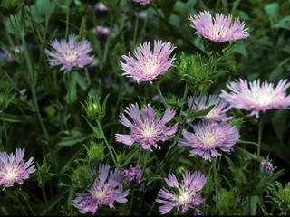
Characteristics: Stokes aster is a low perennial, 12”-18”tall with a basal cluster of dark-green, lance-shaped leaves. The numerous solitary flower heads are 3”- 4”across with deeply divided blue rays and very prominent blue florets from the disk. This species readily self-sows and adapts to many conditions. Blooms May – September (especially if deadheaded) in sun and partial shade with more moist soils.

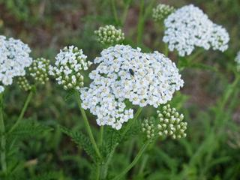
Yarrow / Achillea millefolium

Characteristics: Yarrow grows to 3 feet tall and has flat-topped white flowers that are surrounded by leaves with a delicate, fern-like appearance. It is a great garden plant, as it can be used in fresh or dried arrangements and has a pleasing fragrance. Yarrow grows in sun and partial shade with low water requirements and often stays evergreen through the winter. It is of special value to native bees!

Lanceleaf coreopsis / Coreopsis lanceolata
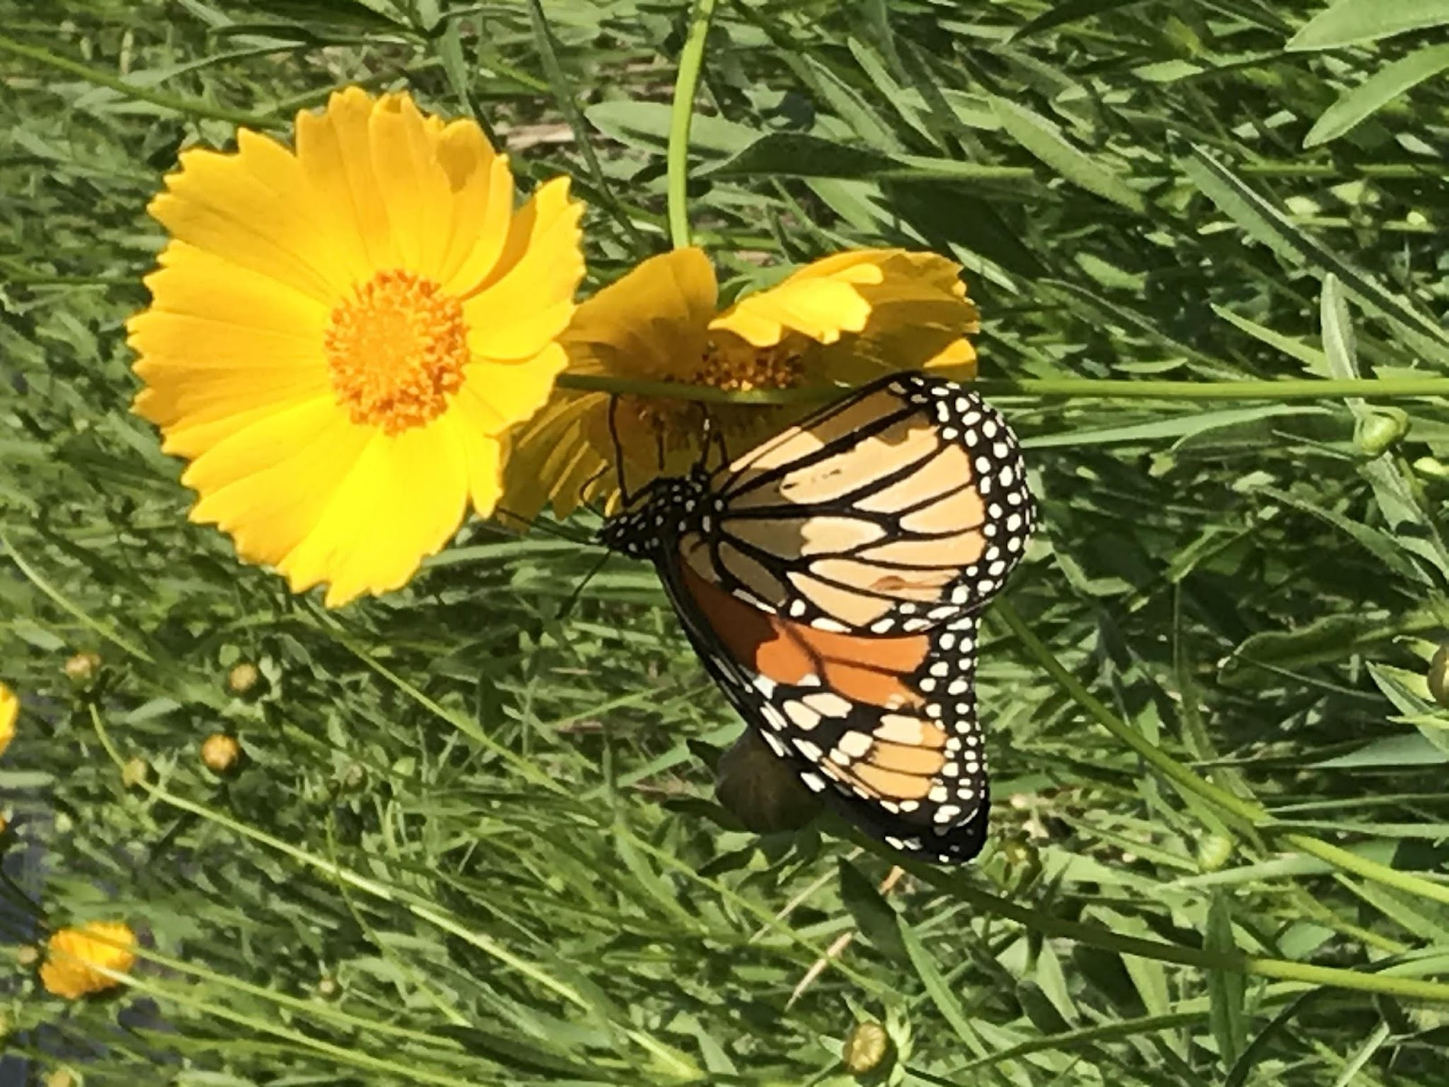
Characteristics: This native species grows in small clumps and forms extensive colonies growing 1-2 ½’ feet tall. The yellow daisy-like flowers occur singly atop long, slender stalks and are butterfly magnets that bloom in April-May. If deadheaded, blooming extends into June. Leaves remain evergreen here in Richmond Hill climate. This image was shot on the bridge to The Coastal Ga’s #5 hole; the whole colony of coreopsis was filled with monarchs and painted lady butterflies.
Landscape Uses: Plant in partial sun or full sun and combine with Georgia Savory, Blue Eyed Grass, Penstemon and Bee Balm for a stunning spring display of colors. Tolerant of dry soils.

Savannah Coreopsis / Coreopsis linifolia
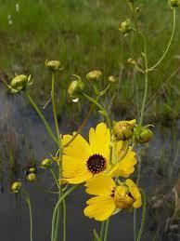
Characteristics: This cheerful plant blooms July, August and September on single or multiple stems with fine narrow leaves in moist soil. Grows 1-3’ in height and 1’ in width.

Landscape Uses: Beautiful when combined with Joe Pye Weed, Blazing Star, Stokes Aster, Beach Goldenrod, Spotted Bee Balm, Milkweed, and ‘Northwind’ Switchgrass – a meadow in the making that will please people and pollinators.

Coneflower/ Echinacea purpurea
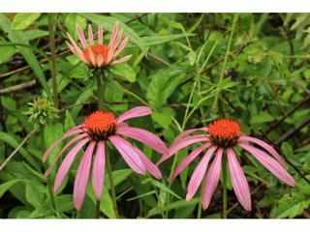
Characteristics: Coneflowers are popular perennials with smooth, 2-5’ stems and long-lasting, lavender flowers. Rough, scattered leaves that become small toward the top of the stem. Flowers occur singly atop the stems and have domed, purplish-brown, spiny centers and drooping, lavender rays. Bloom time is very long: April -September.
Landscape Uses: Echinacea is a beautiful addition to any prairie garden and attractive in flower arrangements. It is especially appealing to hummingbirds, butterflies and essential for honeybees.

Cutleaf Coneflower / Rudbekia lacinata
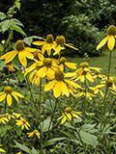
Characteristics: This sunflower-like perennial is crowned with multiple flowering branches; the leafy stalks grow 3-6’ tall. Each flower is 3-4”across, and displays dark yellow cone-shaped centers above back-tilted golden rays. The center cones elongate and become brownish as the seeds ripen. Extended bloom time from July-October makes this plant appealing for fall gardens and is suitable for large areas that need landscaping. Plant in full sun or partial shade with moderate hydration.
Landscape uses: Plant with Swamp Milkweed, Beach Goldenrod, Joe Pye Weed, and ‘Northwind’ Switchgrass for a beautiful textured garden filled with movement.

Grasses and Sedges

Blue-Eyed Grass / Sisyrinchium angustifolium
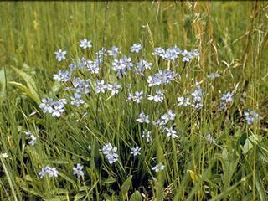

Characteristics: The delicate, blue or deep blue-violet flowers with yellow centers form on narrow stems with light-green leaves and grow into a dense, tufted clumping habit that steadily adds new foliage during the season. A small member of the iris family at 1’-1 ½ ‘ in height, it blooms March through July in the sun and partial shade of meadows, damp fields and in low open woodland settings.

Northwind Switchgrass / Panicum virgatum ‘Northwind’
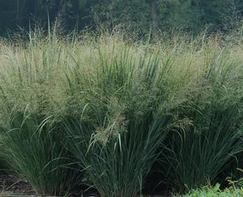

Characteristics: A compact, clumping grass with excellent vertical form, it’s olive to blue-green foliage turns golden yellow in autumn. Airy flower panicles produce showy seed heads and lend winter interest. Sturdy stems stay upright, giving protection to wintering songbirds. Growing 4-5’ high and 3’wide, this grass was named The Perennial Plant Association's 2014 Perennial Plant of the Year since Switchgrass can be used as a groundcover to control erosion and for the transition areas between garden and wood areas. Panicum prefers full sun, and moist, fertile soil; however, the plant will tolerate sand, heavy clay, dry slopes and boggy areas.

Sweet grass or Muhly grass/ Muhlenbergia capillaris

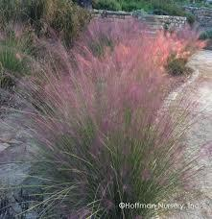

Characteristics: Muhlenbergia make their home in the southern U.S. and Mexico. They often grow in arid or semi-arid regions, with adaptations that make them a good choice for low-water landscapes. This also means they need well-drained soil to remain healthy and survive wet winters. They need full sun and dry conditions to look their best, and may suffer in shade or wet summers. Mature height is 18”-36”

American White Waterlily/Nymphaea odorata
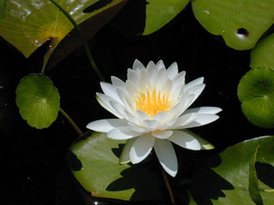
Characteristics: A floating aquatic plant with large, fragrant, white or pink flowers and flat, round, floating leaves. The leaves have long stems and are bright green above and reddish or purplish underneath, almost round. They are up to 10 inches across, floating on the surface of the water or just beneath. There is 1 flower to a stem, white, fragrant, 2-6 inches across, and floating on the water. Flowers open in the early morning and close about noon. They bloom from March- late October. They can tolerate sun- partial shade but require water to float in. Are highly recommended for the lake banks at The Coastal Ga since waterfowl and mammals eat the buoyant seeds and other parts of the plant while fish utilize the cover for breeding and protection from larger predators.

PickerelWeed/Pontederia cordata
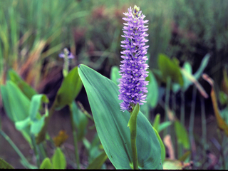
Characteristics: The large pickerel weed plant produces 1 spike of small flowers. The plant is often 3 feet tall, with long, heart-shaped leaves. This emergent aquatic, with its leaves and flowers above water and portions of the stem under water, is found typically in shallow, quiet water. The seeds can be eaten like nuts and the young leaf-stalks cooked as greens. It can tolerate sun to partial shade and is recommended for lake banks.

Swamp Lily/ Crinum americanum
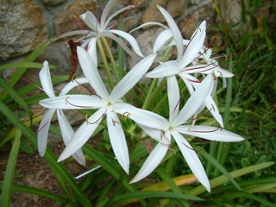

Characteristics: Swamp lilies are erect plants that grow in small clumps. The leaves grow directly from the bulb and are 2-4 feet long and 2-3 inches wide. The flower stem is about 1 inch in diameter, 2-3 feet tall, with 2-6 flowers forming a showy umbel at the top. The fragrant flowers are white, sometimes marked with pink. They bloom from June- November and prefer shade to dappled sun.

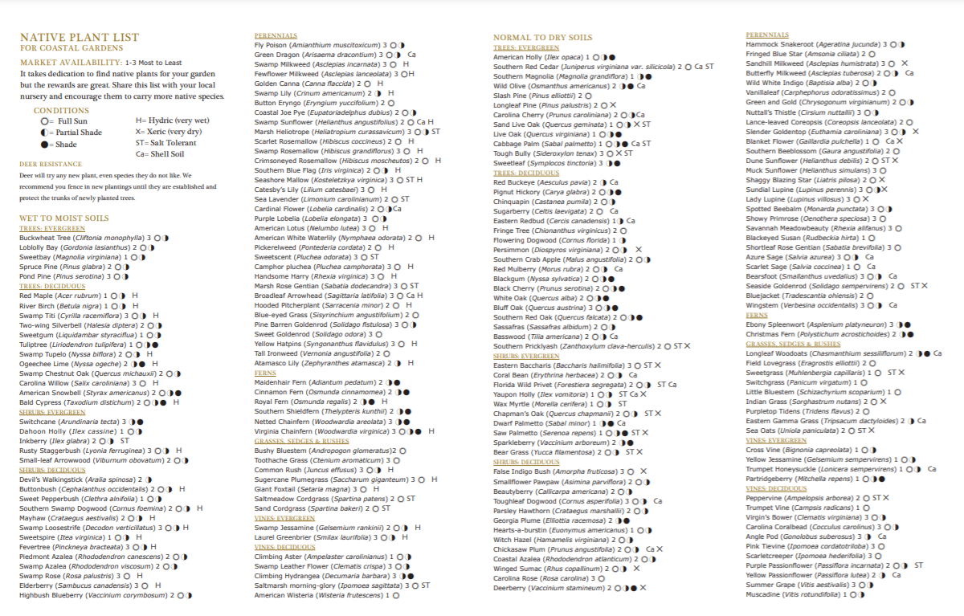
Nature-Based Solutions (NBS)
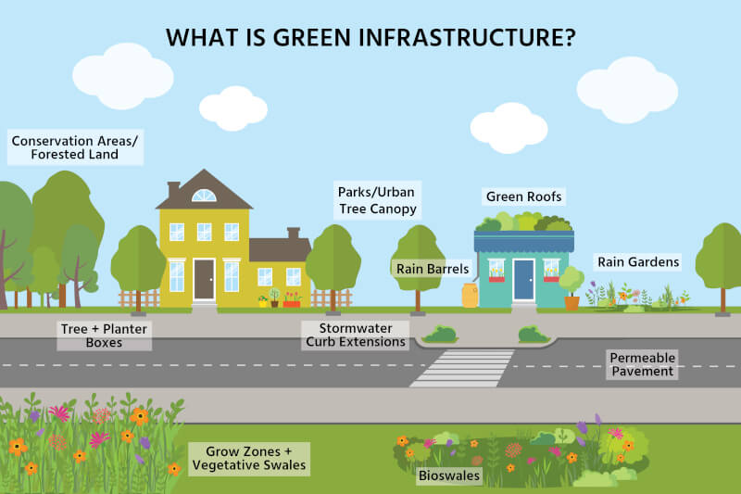

Nature-Based Solutions (NBS) are practices that work with natural systems to address common community challenges such as flooding, erosion, water quality, heat, and wildlife conflicts. In Coastal Georgia, NBS are especially valuable due to our proximity to tidal waters, high rainfall events, and sensitive marsh and estuarine systems. When properly designed and maintained, Nature-Based Solutions often outperform traditional gray infrastructure over time by reducing maintenance costs, improving resilience to storms and sea level rise, and providing ecological benefits that engineered systems cannot.

Why Nature-Based Solutions Matter in Coastal Georgia
Coastal Georgia experiences high rainfall events, flat topography, sandy or compacted soils, and proximity to sensitive estuarine systems. Traditional stormwater infrastructure alone is often overwhelmed during heavy rain and can unintentionally transport pollutants directly into ponds, marshes, and tidal waters.

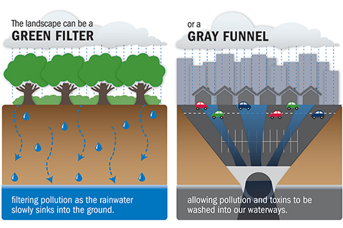

Nature-Based Solutions help:
- Slow, spread, and absorb stormwater before it reaches waterways
- Reduce nutrient and sediment loading into ponds, rivers, and estuaries
- Stabilize shorelines and reduce erosion
- Improve wildlife habitat and connectivity
- Increase community resilience to storms and flooding

Some NBS are more complicated than others and consultations for appropriate NBS can be achieved through the Green Communities Program or by reaching out to UGA Marine Extension or through the GA DNR Coastal Resource Division’s Coastal Management Program.

Common Nature-Based Solutions for Coastal HOAs
Living Shorelines
Living shorelines use native marsh plants, oyster shell, coir logs, and other natural materials to stabilize banks along tidal creeks, rivers, and ponds. Unlike bulkheads or seawalls, living shorelines absorb wave energy rather than reflecting it, reducing erosion over time.
Benefits include:
- Improved water quality and shoreline stability
- Habitat for fish, crabs, oysters, and birds
- Reduced long-term maintenance compared to hardened shorelines
- Increased resilience to sea level rise

Rain Gardens and Bioretention Areas
Rain gardens are shallow, planted depressions designed to collect and filter stormwater runoff from roofs, parking areas, and roadways. These systems temporarily hold water, allowing it to soak into the ground while plants and soils remove pollutants.
Best practices include:
- Locating rain gardens downslope from impervious surfaces
- Using deep-rooted native plants tolerant of both wet and dry conditions
- Designing overflow paths for large storm events

Bioswales and Vegetated Ditches
Bioswales are linear, vegetated channels that slow and filter stormwater while conveying it safely through a site. In many coastal communities, bioswales can replace or retrofit traditional roadside ditches.
Benefits include:
- Reduced erosion and flooding
- Improved water quality before runoff enters ponds or marshes
- Lower maintenance costs compared to hard-lined drainage systems

Native Vegetated Buffers
Maintaining wide, native plant buffers along ponds, marshes, and waterways is one of the most effective and low-cost Nature-Based Solutions available. Buffers filter nutrients, stabilize soils, and provide habitat for wildlife.
Buffers should:
- Be as wide as space allows, with diverse plant layers (trees, shrubs, grasses)
- Avoid fertilizer and pesticide use
- Be managed through selective pruning rather than clearing
Permeable and Green Infrastructure
Permeable pavers, reinforced turf, and gravel systems allow water to infiltrate rather than run off into storm drains. These systems are well-suited for overflow parking, walkways, and low-traffic areas.
Green infrastructure elements can also include:
- Green roofs on community buildings
- Rainwater harvesting systems
- Tree islands within parking areas
Tree Canopy Preservation and Expansion
Trees are one of the most effective natural stormwater management tools. Their canopies intercept rainfall, while their roots improve soil infiltration and stability.
HOAs should prioritize:
- Protecting existing mature trees during development or maintenance
- Planting native canopy species appropriate for coastal conditions
- Avoiding excessive pruning that reduces canopy effectiveness

Maintenance and Long-Term Success
Nature-Based Solutions require maintenance, but typically far less intensive and less costly maintenance than traditional infrastructure when designed correctly. Maintenance should focus on:
- Monitoring plant establishment and replacing failed plants
- Removing invasive species
- Managing sediment buildup where appropriate
- Educating residents on the purpose and function of these systems
Nature-based solutions should be incorporated into community planning early whenever possible. Retrofitting existing infrastructure with NBS can also be effective when paired with regular maintenance and community education.

Community Education and Acceptance
Successful NBS implementation relies heavily on resident understanding and support. Signage, educational materials, and outreach can help residents recognize that these features are intentional, functional, and beneficial—not neglected or unmanaged spaces.
Nature-Based Solutions provide an opportunity for HOAs to lead by example, demonstrating stewardship of coastal resources while enhancing property values, aesthetics, and long-term resilience.

Sustainability in HOAs and Coastal Communities

Sustainability in Coastal Georgia communities means planning for long-term environmental health while balancing financial responsibility, aesthetics, and quality of life for residents. Sustainable communities are better prepared to handle increasing storm intensity, sea level rise, and rising maintenance costs.
Well-designed sustainability efforts do not require drastic change. Many of the most effective actions are incremental, affordable, and can be phased in over time.

Practical Sustainability Actions for HOAs
Water Conservation and Stormwater Management
Water management is one of the most impactful sustainability opportunities for coastal communities.
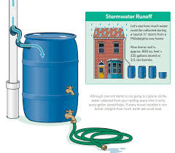
Examples include:
- Rain Barrels and Cisterns: Capturing roof runoff for landscape irrigation reduces potable water use and helps manage stormwater during heavy rain events. These systems can also provide non-potable water for emergencies.
- Efficient Irrigation Systems: Installing rain sensors, soil moisture sensors, and smart controllers prevents unnecessary watering.
- Reducing Turf Areas: Replacing high-maintenance turf with native plants lowers irrigation demand and reduces fertilizer use.
- Directing Runoff to Landscaped Areas: Routing downspouts into rain gardens or vegetated areas rather than hard surfaces.

Reducing Light Pollution
Excessive nighttime lighting disrupts wildlife, affects human health, and wastes energy. Coastal Georgia is especially important for migratory birds, sea turtles, and nocturnal species.
HOAs can reduce light pollution by:
- Installing timers, motion sensors, and photocells on exterior lighting
- Using downward-facing, shielded fixtures to prevent light spill
- Selecting warmer color temperatures instead of bright blue or white lights
- Turning off decorative and landscape lighting during late-night hours
These measures improve safety while preserving dark skies and reducing energy costs.

Energy Efficiency and Renewable Options
Improving energy efficiency lowers operational costs and reduces emissions.
Options include:
- Converting common-area lighting to LED fixtures
- Installing solar-powered lighting for pathways and signage
- Evaluating solar installations on community buildings or amenities
- Improving insulation and ventilation in shared facilities

Waste Reduction and Material Management
Reducing waste saves money and limits environmental impact.
Sustainable practices include:
- Composting landscape debris on-site when feasible
- Mulching leaves and grass clippings instead of hauling them off-site
- Encouraging recycling and proper disposal of hazardous materials
- Reducing single-use items at community events

Landscaping for Long-Term Resilience
Sustainable landscapes are designed to thrive under local conditions rather than relying on constant inputs.
Best practices include:
- Using native and salt-tolerant plants
- Preserving mature trees and natural areas
- Designing plantings to withstand flooding and drought
- Avoiding fertilizers and pesticides near waterways

Community Policies and Education
Sustainability efforts are most successful when supported by clear policies and resident understanding.

HOAs can:
- Adopt sustainability guidelines or resolutions
- Provide educational materials explaining management decisions
- Use signage to explain features like rain gardens or dark-sky lighting
- Encourage resident participation in stewardship activities
The Benefits of Sustainable Communities
- Communities that prioritize sustainability often experience:
- Lower long-term maintenance and utility costs
- Increased resilience to storms and flooding
- Improved wildlife habitat and water quality
- Higher property values and community appeal

By integrating sustainability into everyday decisions, HOAs can protect coastal resources while creating healthier, more resilient communities for current and future residents. Sustainability efforts are most successful when residents understand the purpose behind management decisions. Education, signage, and transparent communication help build community support and reduce resistance to changes in traditional landscaping practices.

Conservation Easements and Open Space Credits in Georgia

Conservation easements and open space preservation are powerful tools for protecting natural areas while offering benefits to both communities and landowners. In Georgia, these tools can help HOAs maintain green space, protect wildlife corridors, and reduce long-term development pressures.
Protecting open space is a critical component of long-term resilience, environmental health, and community character in Coastal Georgia. Tools such as conservation easements, Wildlife Management Areas, conservation subdivisions, and open space credits allow communities to balance growth with stewardship while reducing long-term costs and risks.

Conservation Easements
A conservation easement is a voluntary, legally binding agreement that permanently limits certain types of development on a property in order to protect its conservation values. The land remains privately owned, but future uses are restricted to ensure long-term protection of natural resources.
In Coastal Georgia, conservation easements are commonly used to protect:
- Marsh buffers and tidal creek corridors
- Maritime forests and upland hammocks
- Wetlands and flood-prone lands
- Wildlife corridors and scenic viewsheds
Benefits for HOAs and coastal communities include:
- Permanent protection of sensitive lands without requiring public ownership
- Reduced infrastructure and maintenance costs on undeveloped land
- Preservation of community character and natural aesthetics
- Potential tax incentives for landowners
Easements are typically held by land trusts, conservation organizations, or government entities, which monitor the property to ensure easement terms are upheld.

Wildlife Management Areas (WMAs)
Wildlife Management Areas are lands managed specifically to conserve wildlife habitat while allowing compatible public uses such as hunting, fishing, wildlife viewing, and environmental education. In Coastal Georgia, WMAs often protect large tracts of wetlands, forests, and river corridors that provide critical ecological functions.
For nearby communities and HOAs, WMAs provide:
- Natural flood storage and stormwater absorption
- Protection of wildlife populations and migration routes
- Recreational and educational opportunities for residents
- Buffers between developed areas and sensitive ecosystems
Communities adjacent to WMAs often benefit from increased property values and reduced pressure to develop marginal or flood-prone lands.

Conservation Subdivisions
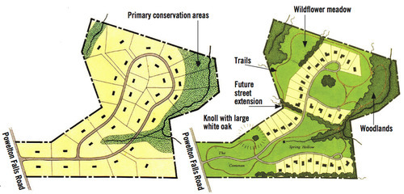

Conservation subdivisions are a development approach that clusters homes on a smaller footprint while permanently preserving a significant portion of the property as open space. This design strategy allows development to proceed while maintaining ecological function and community green space.

Key features include:
- Smaller lot sizes with shared open space
- Preservation of wetlands, forests, and wildlife corridors
- Reduced road length and infrastructure costs
- Enhanced views and access to natural areas for residents
In coastal settings, conservation subdivisions help avoid development in flood-prone areas while maintaining natural drainage patterns and habitat connectivity.

Open Space Credits and Incentives
Many Georgia jurisdictions offer open space credits or incentives through zoning and development regulations. These programs reward developers or communities for permanently protecting natural areas by allowing flexibility in density, layout, or other development standards.
Open space credits may be earned by:
- Preserving wetlands, floodplains, or buffers
- Establishing permanent conservation easements
- Protecting contiguous habitat corridors
- Incorporating Nature-Based Solutions into site design
For HOAs, open space credits can result in:
- Lower long-term maintenance costs
- Reduced stormwater infrastructure requirements
- Increased community appeal and market value
- Improved resilience to flooding and storm impacts

Open Space as a Community Asset
When thoughtfully planned and managed, conserved open space is not unused land—it is a functional community asset. Open space can provide stormwater management, wildlife habitat, recreational opportunities, and protection from future development pressures.
HOAs and coastal communities are encouraged to work with local governments, planners, land trusts, and conservation professionals to identify the most appropriate tools for protecting open space while meeting community goals. Integrating conservation into land-use planning today helps ensure Coastal Georgia communities remain resilient, attractive, and environmentally healthy for generations to come.

For more information about Conservation Lands and Management, please contact Ga DNR Private Lands or your Green Communities Coordinator.

Plants for Erosion Control at the Water’s Edge

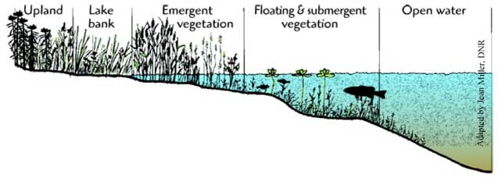
These plants tolerate flooding and help hold the shoreline together directly at the lake edge. Avoid planting turf grass alone on the bank as it has shallow roots and often worsens erosion over time. Native buffer plantings are much more effective at holding soil and filtering runoff. Zone planting for slope stabilization should be placed in each of the zones listed in the below diagram. Each plant is listed below by zone.

Floating & Submergent Plants

American White Waterlily- Native floating-leaved species that are excellent for shallow coves and quiet shorelines

Spatterdock- Native yellow pond lily with strong rhizomes stabilize muddy lake edges

Watershield- Good for calm freshwater ponds, creates shade for fish habitat.

Emergent & Wetland Plants
- Pickerelweed- Excellent root mass for stabilizing muddy edges; pollinator-friendly.
- Lizard’s Tail- Spreading colonies help bind soft soils.
- Soft Rush- Dense clumps are excellent for slowing runoff.
- Arrowhead-Good for shallow-water margins.
- Duck Potato- Useful in fluctuating water levels.
- Blue Flag Iris- Attractive native iris with strong rhizomes.
- Bulrush- Very effective in saturated soils.
- Smooth Cordgrass- Excellent for pond and lake margins in Coastal Georgia; handles wet-dry cycles well.

Lake Bank Plants

Native Grasses & Sedges:
- Switchgrass- One of the best natives for erosion control; deep roots.
- River Oats- Great for shaded banks.
- Broomsedge- Tough and low-maintenance.
- Muhly Grass- Good for upper banks with drier soils.
- Fox Sedge- Excellent for moist transition zones.
- Soft Rush- Also works well higher up the slope.

Upland Plants
Shrubs:
- Buttonbush- One of the best native shrubs for lake edges. Recommended by Georgia CRD.
- Virginia Sweetspire- Excellent spreading root system.
- Wax Myrtle- Fast-growing and salt/wet tolerant.
- Black Titi- Great for moist acidic soils.
- Fetterbush- Good in wet Coastal Plain soils.
- Elderberry- Strong roots and wildlife value.
- Swamp Azalea- Useful in partial shade/moist banks.
Trees (Best used higher on the bank where roots won’t undermine the shoreline edge)
- Bald Cypress- A good long-term shoreline tree for Coastal Georgia freshwater systems overall
- Black Willow- Extremely effective for erosion control and fast-growing.
- Red Maple- Good for moist soils.
- Black Tupelo- Native wetland tree with strong roots.
- River Birch- Excellent on fluctuating shorelines.

Combination Example:
If you want a low-maintenance, highly effective planting palette:
- Water edge: Pickerelweed + Blue Flag Iris
- Mid-slope: Switchgrass + Cut Grass
- Shrub layer: Buttonbush + Virginia Sweetspire
- Upper bank: Bald Cypress
Native Plants to Avoid Using Aggressively
These are native, but can spread aggressively in small ponds. They are still ecologically appropriate natives — just best used intentionally and monitored.
- Coontail
- Maidencane
- Spatterdock
- Softstem Bulrush

DEFINITELY Avoid

These are invasive/problematic aquatics in Georgia. Georgia DNR lists many of these as serious aquatic invasives.

- Hydrilla
- Water Hyacinth
- Parrot Feather
- Alligatorweed
- Giant Salvinia
- Brazilian Elodea
- Eurasian Watermilfoil
References and Resources

https://www.sapelonerr.org

https://coastalecologylab.wixsite.com/gacoast

https://extension.uga.edu/publications/detail.html?number=C985

https://georgiawildlife.com/landowners

https://wildones.org/

https://coastalgadnr.org/LivingShorelines

https://gacoast.uga.edu/research/major-projects/living-shoreline/

https://www.coastalwildscapes.org/
Georgia Native Plant Society(Gnps.org)

